**Egyptian E-Learning University**

Faculty of Computers & Information Technology

Budget Optimization Management system **By**

|  |  |
| --- | --- |
| **Name : Athal Tarek Mohamed Kamel** | **ID : 2100532** |
| **Name : Sara El-amir Mahmoud Youssef** | **ID:** **2101573** |
| **Name : Mohamed Ahmed Shereen** | **ID :2101277** |
| **Name : Farah Mamdouh Riad Hassan** | **ID :** **2100685** |
| **Name :** **Toka Fares Mabrouk Ali** | **ID :** **2100075** |
| **Name : Mohamed Ahmed Maged Mohamed** | **ID :** **2101255** |
| **Name: Mansour Hamed Mohamed Ahmed** | **ID:** **2100964** |

Supervised by

Dr. Rodaina Abdelsalam

Associate Professor - Faculty of Computers and Information TechnologyAssistant

Eng. Nourhan Khashaba

Teaching Assistant, Department of Information Technology

[Assuit]-2025

**Abstract**

This project presents the design and development of an intelligent budgeting system aimed at helping users achieve specific financial saving goals through structured analysis and personalized planning. The system allows users to input detailed monthly financial data, including income, fixed and variable expenses, and a desired saving target.

Based on the provided data, the system utilizes artificial intelligence to analyze spending patterns, detect areas of excessive or unnecessary expenses, and recommend optimized adjustments to various spending categories. It then generates a customized financial plan tailored to the user's financial behavior and capabilities, enabling more effective control over personal budgets.

In addition, the system provides real-time visual feedback using interactive charts and progress indicators to keep users informed and motivated. The goal is to simplify the process of financial management, reduce manual effort, and support the user in staying disciplined and consistent throughout the saving journey.

By promoting financial awareness and providing intelligent recommendations, the project contributes to the development of healthier financial habits. It serves as a practical tool for individuals seeking to improve their budgeting practices, reach personal financial milestones, and maintain long-term stability through better spending decisions.

**Acknowledgments**

First and foremost, we would like to thank and praise God for His countless blessings and guidance throughout this journey.

We are deeply grateful to **Dr. Rodina Abdelsalam** for her continuous support, encouragement, and the valuable advice she provided, which played a key role in shaping the success of this project.

We would also like to express our sincere appreciation to **Eng. Nourhan Khasba**, the assistant lecturer, for her outstanding efforts, guidance, and dedication during all stages of the project.

Finally, we extend our thanks to all the professors and engineers at the Faculty of Computers and Information Technology for their knowledge, mentorship, and for always striving to provide us with the best learning environment and support.

Contents

[**Abstract** 2](#_Toc200477149)

[**Acknowledgments** 4](#_Toc200477150)

[**1.2 Background and Motivation for the Project** 8](#_Toc200477151)

[**1.3 Importance of the Problem Being Addressed** 9](#_Toc200477152)

[**1.4 Problem Statement** 9](#_Toc200477153)

[**1.5 Objectives** 11](#_Toc200477154)

[**1.6 Brief Overview of the Proposed Solution** 12](#_Toc200477155)

[**1. Mint** 14](#_Toc200477156)

[**2. YNAB (You Need A Budget)** 15](#_Toc200477157)

[**3. PocketGuard** 16](#_Toc200477158)

[**4. GoodBudget** 16](#_Toc200477159)

[**5. Qapital** 17](#_Toc200477160)

[**6. Research & Academic Work** 18](#_Toc200477161)

[**Summary of Existing Research and Technologies** 19](#_Toc200477162)

[**Introduction** 21](#_Toc200477163)

[**3.1. Approach Used to Solve the Problem** 22](#_Toc200477164)

[3.2 System architecture 23](#_Toc200477165)

[**Entity-Relationship Diagram (ERD)** 23](#_Toc200477166)

[**3. 3Algorithms or Frameworks Used** 33](#_Toc200477167)

[**4.1 Front-End Overview** 35](#_Toc200477168)

[**4.1.1 Core Programming Language** 35](#_Toc200477169)

[**4.1.2 Framework and Libraries** 36](#_Toc200477170)

[**4.1.3 Styling and Layout** 37](#_Toc200477171)

[**4.1.4 State Management and Data Flow** 38](#_Toc200477172)

[**4.1.5 Development Environment and Tooling** 39](#_Toc200477173)

[**4.2 Component Structure** 40](#_Toc200477174)

[**4.2.1 Home (Dashboard) – Home.jsx** 40](#_Toc200477175)

[**4.2.2 Settings Page – Settings.jsx** 41](#_Toc200477176)

[**4.2.3 Feedback Page – Feedback.jsx** 42](#_Toc200477177)

[**4.2.4 Help Page – HelpPage.jsx** 43](#_Toc200477178)

[**4.2.5 History Page (Planned Component)** 43](#_Toc200477179)

[**4.2.6 Input Page (Form Submission to Backend)** 44](#_Toc200477180)

[**4.2.7 Additional Pages** 44](#_Toc200477181)

[**4.3 Challenges Faced and How They Were Resolved** 44](#_Toc200477182)

[**4.3.1 Dynamic Data Visualization Across Devices** 45](#_Toc200477183)

[**4.3.2 Reusable and Maintainable State Management** 45](#_Toc200477184)

[**4.3.3 Profile Picture Uploads and Handling Binary Data** 46](#_Toc200477185)

[**4.3.4 Accessibility and User-Centered Design** 46](#_Toc200477186)

[**4.3.5 Secure Authentication and User Data Handling** 47](#_Toc200477187)

[**4.3.6 Ensuring Feedback Submission Validity** 47](#_Toc200477188)

[**4.4 Machine Learning Model for Budget Optimization** 47](#_Toc200477189)

[**4.4.1 Purpose and Approach** 48](#_Toc200477190)

[**4.4.2 Data Input and Preprocessing** 48](#_Toc200477191)

[**4.4.3 Model Implementation** 49](#_Toc200477192)

[**4.4.4 Integration with Front-End** 53](#_Toc200477193)

[**4.4.5 Tools and Libraries** 55](#_Toc200477194)

[**4.4.6 Challenges and Resolutions** 56](#_Toc200477195)

[**4.4.7 Future Enhancements** 57](#_Toc200477196)

[Feature Engineering & Preprocessing Workflow 69](#_Toc200477197)

[Financial Savings Prediction Pipeline 78](#_Toc200477198)

[5.1 Testing Strategies 83](#_Toc200477199)

[5.2 Performance Metrics 86](#_Toc200477200)

[5.3 Comparison with Existing Solutions 89](#_Toc200477201)

[**Results & Discussion** 90](#_Toc200477202)

[**6.1 Introduction** 90](#_Toc200477203)

[**Conclusion & Future Work** 98](#_Toc200477204)

Chapter 1

**1.1 Introduction**

Managing personal finances is an essential part of daily life. However, many individuals face difficulties in keeping track of their income and expenses, which often results in failing to reach their financial goals. Budgeting is either ignored or approached in a manual and unstructured way.

This project introduces a smart budgeting system aimed at helping users achieve a specific saving goal by analyzing their income and spending habits. The system provides AI-powered suggestions to reduce unnecessary expenses and offers a structured financial plan with visual tracking to support better decisions and sustainable financial behavior.

**1.2 Background and Motivation for the Project**

The motivation behind this project stems from the observation that many individuals, especially young adults, fail to maintain financial control. Most of them do not keep records of their monthly expenses, let alone plan for future savings. Even when users are aware of their financial habits, they often lack the tools or motivation to modify them. Existing applications typically offer static charts or manual entry options but rarely provide dynamic advice that evolves with the user’s behavior.

Given the increasing cost of living and the psychological burden that financial instability can create, there is a pressing need for systems that not only monitor finances but actively help users improve them. Our goal is to offer a system that is intelligent, user-friendly, and tailored to personal saving targets, making the budgeting process less intimidating and more goal-oriented.

**1.3 Importance of the Problem Being Addressed**

Financial mismanagement can lead to serious long-term consequences, including debt, stress, lack of emergency funds, and inability to achieve life goals such as education, housing, or retirement. In a society where consumerism is high and financial literacy is often low, people need accessible solutions that guide them through responsible money management.

By addressing this problem, our project contributes to enhancing financial awareness at an individual level and reducing the risks associated with unplanned spending. It also provides an opportunity to introduce AI-driven support in a domain where personalized guidance has historically been limited. Solving this problem will not only benefit individuals but also help build healthier financial habits across communities.

**1.4 Problem Statement**

In today’s digital age, people are surrounded by endless spending temptations from online shopping to subscription-based services and this has made it increasingly difficult for individuals to manage their personal finances effectively. Despite the availability of numerous financial tools and mobile applications, most people still fail to reach their saving goals. This is mainly due to the lack of intelligent features in existing systems that can provide dynamic, customized financial advice tailored to the user’s lifestyle and behavior.

Traditional budgeting methods, such as spreadsheets or manual tracking, require constant user input and discipline, which often results in users abandoning them within weeks. Even modern financial apps mostly focus on tracking and visualizing data, but not guiding users on **how** to improve or make smarter spending choices.

The main problem lies in the absence of a smart, automated, and goal-focused solution that not only tracks expenses but also assists users in building a clear path toward their financial objectives. People need a system that not only simplifies budgeting but

actively contributes to decision-making by identifying wasteful patterns, suggesting alternatives, and helping the user commit to their saving journey. There is a growing need for a personalized tool that bridges the gap between awareness and action.

**1.5 Objectives**

**Main Objectives:**

* To create a smart budgeting system that helps users achieve specific saving goals in a practical and efficient way.
* To analyze user financial behavior using AI in order to identify unnecessary expenses.
* To provide customized saving strategies that align with each user's income, lifestyle, and spending habits.
* To simplify the budgeting process by offering automated guidance, visual tools, and continuous feedback.

**Specific Objectives:**

* To provide a user-friendly interface for entering monthly income, expenses, and saving targets.
* To use artificial intelligence to detect spending patterns and identify areas of overspending.
* To categorize expenses and evaluate the impact of each category on overall financial health.
* To suggest practical and personalized cost-cutting strategies without affecting essential needs.
* To generate dynamic saving plans that adapt to user input and behavior over time.
* To provide visual feedback using graphs and progress bars for better understanding and motivation.
* To encourage long-term financial discipline and better budgeting habits.
* To measure the system's performance through user feedback and financial progress tracking.
* To promote financial literacy by helping users understand the reasoning behind each suggestion.

**1.6 Brief Overview of the Proposed Solution**

The proposed solution is a smart, web-based budgeting system designed to assist users in reaching specific financial saving goals through personalized, data-driven guidance. The system combines ease of use with the power of artificial intelligence to analyze users’ income and expenses and generate a clear, actionable plan to optimize their budgets and maximize their savings.

Users begin by entering their monthly income, fixed expenses (such as rent, bills), variable expenses (such as food, entertainment), and the amount they aim to save. The system then processes this data to detect areas of high spending and identifies opportunities for cost reduction in each category. Unlike traditional budgeting tools that merely track expenses, this system acts as a virtual advisor, actively guiding the user on how to reduce unnecessary spending while maintaining a reasonable standard of living.

To enhance user experience and motivation, the system offers dynamic dashboards, visual reports, and progress indicators that show how close the user is to reaching their goal. It adapts its suggestions over time based on real user behavior and changes in

spending patterns, making the advice increasingly accurate and relevant. Additionally, the system provides educational insights and tips to help users better understand their financial decisions.

In essence, the system is designed not just to help users plan a budget, but to actually achieve it with real-time feedback, personalized recommendations, and a focus on long-term financial wellness.

Chapter 2

**Literature Review / Related Work**

**1. Mint**

**Description**:  
Mint is one of the most widely used personal finance apps. It connects to bank accounts to automatically track and categorize transactions (e.g., groceries, utilities, entertainment).

**Key Features**:

* Budget tracking and categorization
* Alerts for overspending
* Free credit score monitoring

**Limitations**:

* It does not suggest how to adjust category-level spending to reach a future savings goal.
* No prediction of time required to save a target amount.

**2. YNAB (You Need A Budget)**

**Description**:  
YNAB is a proactive budgeting app focused on giving every dollar a job. Users manually assign income to different expense categories and savings goals.

**Key Features**:

* Goal-based budgeting (e.g., save $500 in 3 months)
* Real-time budget adjustment
* Emphasis on financial awareness and behavior

**Limitations**:

* Relies heavily on manual input and planning.
* Does not use AI to suggest optimized category-wise adjustments or predict savings timelines.

**3. PocketGuard**

**Description**:  
PocketGuard connects to financial accounts and shows how much money is “safe to spend” after accounting for bills, goals, and necessities.

**Key Features**:

* Real-time "leftover" calculator
* Bill tracking and detection
* Automatic categorization

**Limitations**:

* Focuses on general safe-to-spend calculations rather than personalized saving strategies.
* No detailed projections or category-specific saving optimizations.

**4. GoodBudget**

**Description**:  
GoodBudget uses the traditional envelope budgeting method. Users set digital envelopes for each expense category and manually track spending.

**Key Features**:

* Manual transaction input
* Family/partner sharing
* Strong focus on conscious spending

**Limitations**:

* Manual nature can be tedious.
* No intelligence behind savings prediction or suggestion engine.

**5. Qapital**

**Description**:  
Qapital helps users save through goal-based automation rules (e.g., round-up purchases, save $5 every Monday).

**Key Features**:

* Rule-based savings automation
* Goal-based planning
* Encourages small, habitual saving

**Limitations**:

* Saving decisions are rule-driven, not income-expense optimized.
* Lacks predictive modeling or breakdown of savings by category.

**6. Research & Academic Work**

**Research:**  
“Machine Learning Applications in Personal Finance Management” (IEEE, 2021) explored:

* Using regression models to predict monthly savings
* Clustering users by spending behavior
* Automating recommendations based on historical patterns

**Limitations Noted**:

* Models often generalized and did not consider user-defined savings goals or personalized timelines.
* Few implementations integrated both prediction and optimization for actionable recommendations.

**Summary of Existing Research and Technologies**

Many personal finance management (PFM) tools exist to help users track expenses, create budgets, and save money. Popular apps like **Mint**, **YNAB**, **PocketGuard**, **GoodBudget**, **Qapital**, **Digit**, and **Cleo** offer features such as budget tracking, automatic categorization, goal-based savings, and spending alerts. Some apps use basic automation or AI for saving small amounts (e.g., Qapital, Digit), while others focus on manual budgeting and financial awareness (e.g., YNAB, GoodBudget).

However, most tools are either **reactive** (they report what has already been spent) or provide **generic rules** for saving, without personalized guidance. While AI and machine learning are slowly being introduced into financial planning apps, existing systems lack the ability to:

* Recommend **how much to reduce from each expense category** to reach a specific savings goal.
* **Predict the time required** to achieve a desired savings target based on current income and expenses.

Academic research has explored machine learning for financial prediction and behavior analysis, but practical applications often fail to bridge the gap between **forecasting** and **personalized, goal-driven financial advice**.

My project fills this gap by combining **goal-based savings prediction**, **category-level expense adjustment**, and **timeline forecasting**, offering users intelligent, actionable financial planning

Chapter 3

**Proposed system**

**Introduction**

The backend of the Budget Management System was developed using **ASP.NET Core**, designed to provide a secure and scalable API that connects the frontend with a machine learning model to generate personalized financial plans. It manages user data, handles authentication, stores inputs/goals/plans, and ensures seamless integration with the AI engine.

This section provides a detailed look into the approach taken and the tools used to solve the business problem from a backend perspective.

**3.1. Approach Used to Solve the Problem**

The backend was structured using a layered architecture to promote maintainability and scalability. The primary steps involved:

* **User Management**: Handling user registration, login, and data storage.
* **Financial Data Capture**: Accepting user input such as expenses and financial goals.
* **AI Model Integration**: Sending user data to an external machine learning model (via HTTP) and receiving a suggested financial plan.
* **Database Storage**: Storing all user inputs, goals, and AI-generated plans in a SQL Server database using **Entity Framework Core**.
* **Security**: Protecting all API endpoints using JWT tokens to ensure only authenticated users can access their data.
* **Documentation & Testing**: Using Swagger for documenting and testing APIs during development.

The backend is stateless and can run on any cloud provider or local server, making it adaptable to various deployment environments.

3.2 System architecture

**Entity-Relationship Diagram (ERD)**

The Entity-Relationship Diagram (ERD) illustrates the database structure of the Budget Management System, detailing the entities, their attributes, and the relationships between them. This diagram serves as the foundation for designing the database schema and ensures that all data requirements are met for the system's functionality.

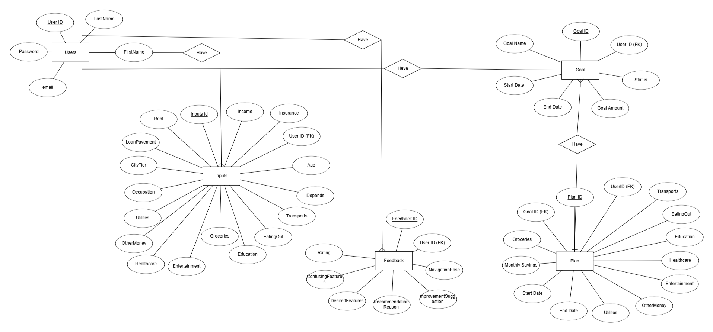

**Entities and Attributes**:

* + **Users**: Stores user information with attributes like UserID (PK), FirstName, LastName, Password, and email.
  + **Inputs**: Captures the user's financial data, including InputsID (PK), UserID (FK), CityTier, Rent, LoanPayment, Income, Insurance, Age, Depends, Transports, EatingOut, Education, Utilities, Groceries, OtherMoney, Healthcare, Entertainment, and Occupation.
  + **Goal**: Represents financial goals with attributes like GoalID (PK), UserID (FK), GoalName, GoalAmount, StartDate, EndDate, and Status.
  + **Plan**: Defines the budget plans with attributes like PlanID (PK), UserID (FK), GoalID (FK), MonthlySavings, Groceries, Transports, EatingOut, Education, Healthcare, Entertainment, Utilities, OtherMoney, StartDate, and EndDate.
  + **Feedback**: Stores user feedback with attributes like FeedbackID (PK), UserID (FK), Rating, Confusing\_Feature, DesiredFeature, ImprovementSuggestion, NavigationEase, and Reason.
* **Relationships**:
  + A **User** can have multiple **Inputs**, **Goals**, **Plans**, and **Feedback** (One-to-Many relationships).
  + A **Goal** can be associated with multiple **Plans** (One-to-Many relationship).

The ERD ensures that the database is structured to support the core functionalities of the system, such as storing user financial data, generating budget plans, and collecting feedback. It also provides a clear blueprint for implementing the database using a relational database management system (RDBMS).

**Schema**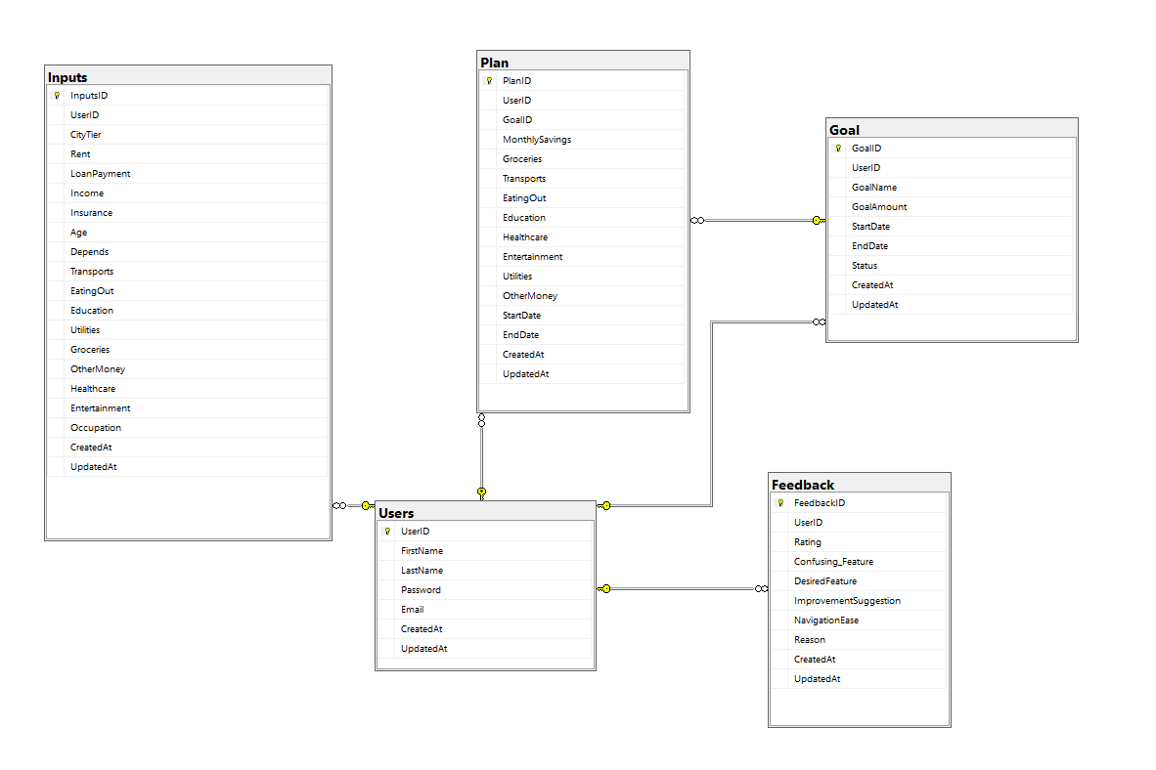

**UML Use Case Diagram** 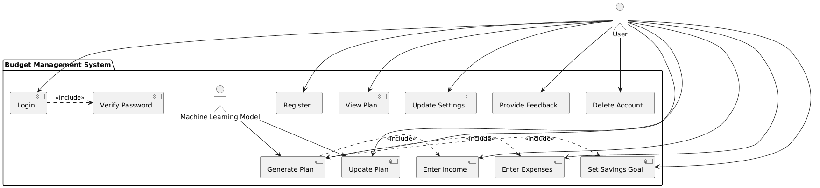

The UML Use Case Diagram outlines the primary functionalities of the Budget Management System from the perspectives of the end-user (User) and an internal Machine Learning Model. It depicts the interactions between these actors and the system's features, including:

* **Login**: Allows the user to access the system, including a «Verify Password» sub-task to authenticate credentials.
* **Register**: Enables the user to create a new account.
* **Enter Income**: Allows the user to input their income data.
* **Enter Expenses**: Allows the user to input their expense data.
* **Set Savings Goal**: Enables the user to define a financial savings goal.
* **Generate Plan**: Generates a budget plan, requiring «Enter Income», «Enter Expenses», and «Set Savings Goal» as prerequisites. The Machine Learning Model analyzes the input data to assist in creating an optimized plan.
* **Update Plan**: Updates the budget plan based on new data, with the Machine Learning Model providing analysis for optimization.
* **View Plan**: Allows the user to view their generated plan.
* **Update Settings**: Allows the user to modify account settings.
* **Provide Feedback**: Enables the user to submit feedback about the system.
* **Delete Account**: Allows the user to permanently delete their account.

The diagram uses «include» relationships to show dependencies, such as the need for «Verify Password» during Login, and the reliance of «Generate Plan» on entering income, expenses, and a savings goal. The Machine Learning Model, as an internal actor, interacts with «Generate Plan» and «Update Plan» to enhance the system's ability to create and refine budget plans. This visualization helps stakeholders understand system capabilities, user workflows, and the role of machine learning in improving functionality, ensuring comprehensive coverage during development and testing.

**UML Class Diagram**

The Class Diagram provides a static view of the Budget Management System’s architecture, detailing the main classes, their attributes, methods, and relationships. It serves as a blueprint for implementing the domain model and managing data through Object-Relational Mapping (ORM) tools.

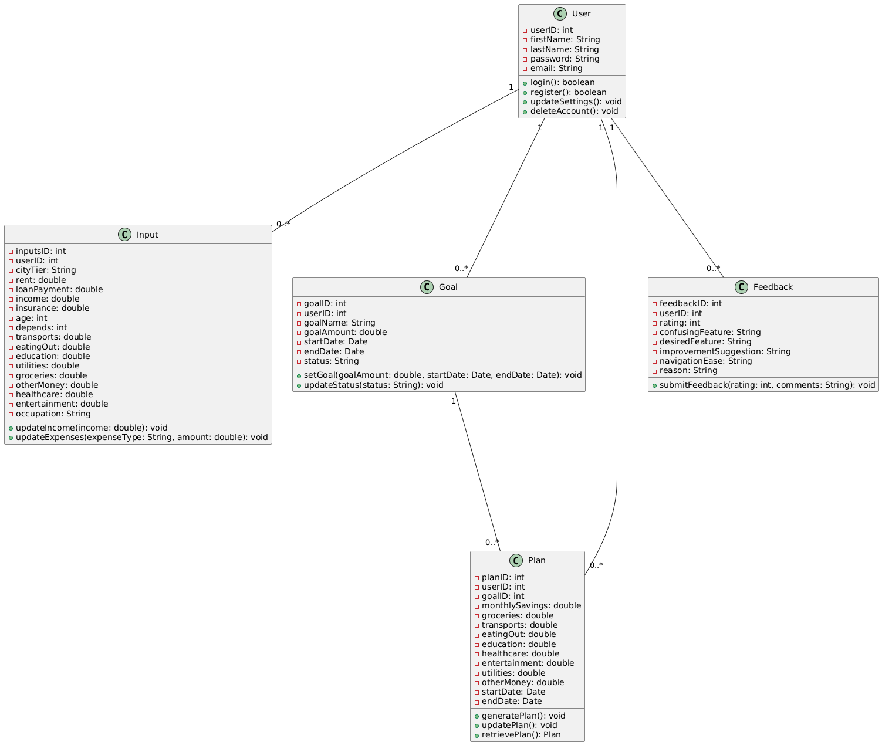

* **Classes and Attributes**:
  + **User**: Represents a system user with attributes like userID: int, firstName: String, lastName: String, password: String, and email: String. Methods include login(), register(), updateSettings(), and deleteAccount().
  + **Input**: Captures financial inputs with attributes like inputsID: int, userID: int, income: double, rent: double, and others (e.g., groceries: double, healthcare: double). Methods include updateIncome() and updateExpenses().
  + **Goal**: Represents financial goals with attributes like goalID: int, userID: int, goalName: String, goalAmount: double, startDate: Date, endDate: Date, and status: String. Methods include setGoal() and updateStatus().
  + **Plan**: Represents budget plans with attributes like planID: int, userID: int, goalID: int, monthlySavings: double, and expense categories (e.g., groceries: double). Methods include generatePlan(), updatePlan(), and retrievePlan().
  + **Feedback**: Stores user feedback with attributes like feedbackID: int, userID: int, rating: int, confusingFeature: String, and improvementSuggestion: String. Methods include submitFeedback().
* **Relationships**:
  + **User** has a one-to-many relationship with **Input**, **Goal**, **Plan**, and **Feedback**.
  + **Goal** has a one-to-many relationship with **Plan**, as a single goal can be associated with multiple plans.

The Class Diagram ensures proper data encapsulation and adherence to object-oriented principles, promoting code maintainability and scalability. It directly aligns with the ERD, facilitating the mapping of classes to database tables.

**UML Sequence Diagram**

The Sequence Diagram illustrates the dynamic interactions between system components over time for key functionalities of the Budget Management System. It captures the order and flow of messages exchanged between the User, AuthenticationService, BudgetManagementSystem, PlanService, FeedbackService, and SettingService.

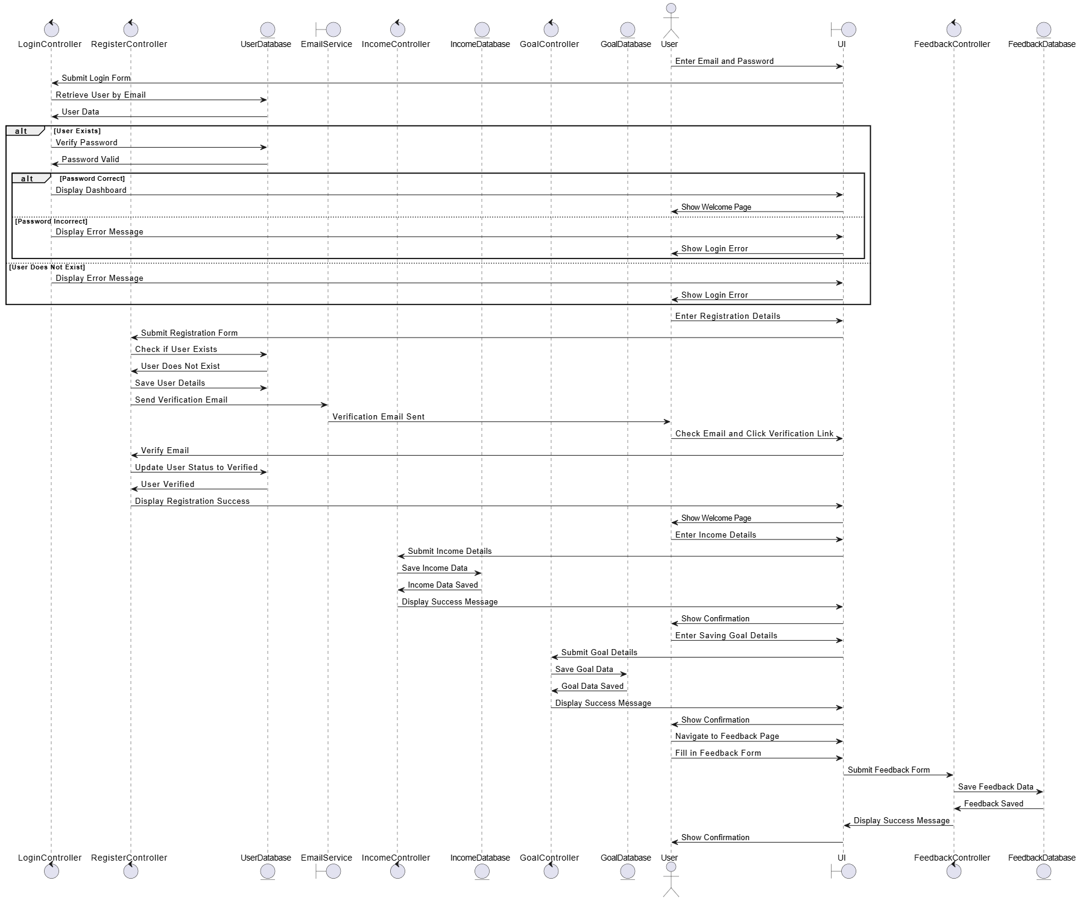

* **Key Scenarios**:
  + **Login**: The User sends a login request, which the BudgetManagementSystem forwards to the AuthenticationService for credential verification, returning a success message upon completion.
  + **Enter Income/Expenses**: The User submits income or expenses, prompting the BudgetManagementSystem to update the data and request a plan update from the PlanService.
  + **Set Savings Goal**: The User sets a savings goal, which the BudgetManagementSystem updates and triggers a plan recalculation via the PlanService.
  + **View Plan**: The User requests to view their plan, leading the BudgetManagementSystem to retrieve and display the plan through the PlanService.
  + **Provide Feedback**: The User submits feedback, which the BudgetManagementSystem forwards to the FeedbackService for storage.
  + **Update Settings**: The User updates their settings, with the BudgetManagementSystem delegating the task to the SettingService.
  + **Delete Account**: The User requests account deletion, which the BudgetManagementSystem processes through the AuthenticationService.

This diagram provides a runtime view of the system, showing how responsibilities are distributed across services and how updates (e.g., plan recalculations) are triggered. It is particularly valuable for understanding service coordination in a service-based architecture, aiding developers in implementing and debugging the system.

**3. 3Algorithms or Frameworks Used**

* **Framework**: ASP.NET Core 8.0 (Web API)
* **ORM**: Entity Framework Core (code-first approach)
* **Authentication**: JWT (JSON Web Token) for secure and stateless auth
* **Dependency Injection**: Built-in ASP.NET DI container for service/repo injection
* **External ML Communication**: HttpClient used to send and receive data from a FastAPI-based ML model
* **Database**: Microsoft SQL Server
* **API Testing**: Swagger (OpenAPI)
* **DTO Mapping**: Custom DTO classes used for clean data transfer between client and server
* **Exception Handling**: Global exception middleware and custom error responses

Chapter 4

**Implementation**

This chapter outlines the technical implementation of the budget optimization system, covering both the front-end development (Sections 4.1 to 4.3) and the newly integrated machine learning component (Section 4.4).

**4.1 Front-End Overview**

The front-end was built using a modern web technology stack to ensure modularity, responsiveness, performance, and maintainability, aligning with the project’s goal of simplifying financial management.

**4.1.1 Core Programming Language**

**JavaScript (ES6+)**: JavaScript, leveraging ECMAScript 2015 (ES6) and later features, forms the foundation of the front-end. Features such as arrow functions, *async/await* for asynchronous operations, and destructuring were employed to enhance code readability and maintainability. For example, *async/await* streamlined API calls in components like *Home.jsx* and *Settings.jsx*, ensuring smooth data fetching from the back-end.

**4.1.2 Framework and Libraries**

**React.js (v18+)**

React.js was chosen as the primary framework due to its component-based architecture, virtual DOM for efficient rendering, and robust ecosystem. It enabled the development of reusable components (e.g., Home.jsx, Settings.jsx, Feedback.jsx) that encapsulate specific functionalities, promoting separation of concerns and facilitating testing and maintenance. React’s declarative syntax simplified UI updates based on state changes, crucial for dynamic features like the expense breakdown pie chart.

**React Router**

React Router facilitated client-side routing, enabling seamless navigation across pages such as Login, Signup, Home, Settings, Feedback, and Help. Route guards were implemented to restrict access to authenticated routes (e.g., Home and Settings), enhancing security by redirecting unauthenticated users to the login page.

**React Bootstrap**

React Bootstrap provided a library of pre-built, responsive UI components, accelerating development and ensuring a consistent, professional design. Components like <Container>, <Row>, <Col>, <Form>, <Button>, and <Alert> were used extensively for layout, user input, and feedback display, ensuring adaptability across devices from smartphones to desktops.

**Recharts**

Recharts, a charting library built for React, was integrated into the Home/Dashboard component to visualize financial data. It rendered interactive pie charts showing expense category distributions, enhancing user understanding of their budget allocation with minimal coding effort.

**React Icons**

The react-icons/fi package supplied icons (e.g., <FiShoppingCart /> for groceries, <FiSave /> for savings) displayed alongside expense categories on the Home page. These icons improved the interface’s intuitiveness, aligning with the project’s goal of simplifying the financial journey.

**4.1.3 Styling and Layout**

**CSS Modules**

CSS Modules (e.g., Home.module.css, Help.module.css) were used to scope styles locally to components, preventing naming conflicts and ensuring maintainability. This approach allowed tailored styling, such as custom backgrounds for expense cards and FAQ sections, without affecting the global stylesheet.

**Bootstrap Utility Classes**

Bootstrap’s utility classes (e.g., text-center, mb-4, col-md-6) were employed for responsive layouts, spacing, and alignment. These classes ensured that the interface adapted fluidly to various screen sizes, meeting the requirement of responsiveness across PCs, laptops, tablets, and smartphones.

**4.1.4 State Management and Data Flow**

**React Hooks (useState, useEffect, useRef)**

React Hooks managed state and side effects within functional components. useState handled local state (e.g., form inputs in Settings.jsx), useEffect managed lifecycle events like data fetching (e.g., in Home.jsx), and useRef facilitated DOM interactions, such as triggering file uploads in the Settings page.

**Axios**

Axios served as the HTTP client for back-end communication, with two instances configured: one for application/json requests (e.g., profile updates) and another for multipart/form-data requests (e.g., profile picture uploads). Its promise-based API simplified error handling and data retrieval, as seen in userProfileService.js.

**Axios Interceptors**

Interceptors were implemented to automatically attach the JWT token (stored in localStorage) to every request, centralizing authentication logic. This ensured secure API interactions across components like Settings and Feedback, meeting the project’s security requirements.

**4.1.5 Development Environment and Tooling**

**Vite**

Vite was selected as the build tool and development server, leveraging its fast hot module replacement (HMR) and optimized production builds. Environment variables (e.g., import.meta.env.VITE\_API\_BASE) allowed flexible configuration, defaulting to the production URL https://graduproj.runasp.net.

**Figma**

Figma was used for designing wireframes and prototypes, enabling the team to collaboratively plan layouts, spacing, and interactions. This ensured that the UI aligned with the project’s vision of empowering users with a clear financial interface.

**Visual Studio Code (VS Code) with ESLint and Prettier**

VS Code served as the primary IDE, with ESLint enforcing coding standards and Prettier ensuring consistent formatting. This combination minimized syntax errors and improved collaboration among team members, critical given the project’s time-intensive development during the senior year.

**4.2 Component Structure**

The front-end architecture comprises modular components, each designed to fulfill specific user needs while adhering to React best practices. These components integrate with React Router for navigation, Axios for API communication, and React Hooks for state management, delivering a cohesive user experience.

**4.2.1 Home (Dashboard) – Home.jsx**

The Home component acts as the central dashboard, presenting users with their current financial plan and saving goals.

**Functionality:**

• Fetches data via getCurrentPlan() from the back-end API.  
• Displays the saving goal’s name, target amount, start/end dates, and status.  
• Lists expense categories (e.g., Groceries, Transport, Monthly Savings) with budgeted amounts in Egyptian Pounds (L.E.).  
• Visualizes expense distribution (excluding savings) using a Recharts pie chart with tooltips.

**UI Features:**

• Expense cards dynamically rendered with distinct colors (e.g., primary, secondary, danger) and icons from react-icons/fi.  
• Responsive layout using Bootstrap’s grid system, ensuring readability on all devices.

**4.2.2 Settings Page – Settings.jsx**

The Settings page enables users to manage their profile and account settings securely.

**Profile Management:**

• Users can update personal details (first name, last name, email, country) via React Bootstrap forms with client-side validation.

**Profile Picture Upload:**

• Supports uploading or deleting profile images, with live previews using URL.createObjectURL(). Uses useRef to trigger file input and conditional POST/PUT requests based on existing pictures.

**Password Change:**

• A multi-field form (current password, new password, confirmation) triggers a verification process via a VerifyCode modal, enhancing security.

**Danger Zone:**

• Offers account deletion with a confirmation dialog, ensuring user intent is verified before permanent action.

**4.2.3 Feedback Page – Feedback.jsx**

The Feedback page collects user input to improve the system.

**Form Structure:**

• Includes radio buttons for navigation ease and satisfaction ratings (1-5), plus text areas for qualitative feedback (e.g., confusing features, suggestions).

**Submission:**

• Submits data to https://graduproj.runasp.net/api/Feedback using fetch() with JWT authorization. Front-end validation prevents incomplete submissions.

**4.2.4 Help Page – HelpPage.jsx**

The Help page provides an FAQ section to assist users.

**Structure:**

• Organized into categories (General Questions, Getting Started, Troubleshooting) with collapsible items for better navigation.

**UI Enhancements:**

• Features a scroll-to-top button (visible after 400px scroll), styled with CSS Modules for a polished look.

**4.2.5 History Page (Planned Component)**

**Purpose:**

• Displays past saving goals and associated plans, offering insights into financial progress over time.

**Status:**

• Planned for future implementation, pending back-end integration for historical data retrieval.

**4.2.6 Input Page (Form Submission to Backend)**

**Purpose:**

• Collects user financial data (e.g., income, rent, groceries) and saving goals (name, amount) in Egyptian Pounds.

**Data Structure:**

• Submitted as JSON objects to the back-end, feeding the machine learning model for budget optimization.

**4.2.7 Additional Pages**

**Landing, Login, and Signup Pages:**

• Serve as entry points, with the Landing page introducing the system’s value proposition (“Empower your financial future”), and Login/Signup handling authentication.

**4.3 Challenges Faced and How They Were Resolved**

Development presented several technical and design challenges, addressed through systematic solutions to ensure a robust front-end.

**4.3.1 Dynamic Data Visualization Across Devices**

**Problem:**

Rendering pie charts and expense lists dynamically across screen sizes caused overflow and spacing inconsistencies, particularly on smartphones.

**Solution:**

Employed Bootstrap’s responsive grid system (col-sm-6, col-md-4) for layout flexibility. Wrapped Recharts’ PieChart in a ResponsiveContainer, ensuring fluid resizing and maintaining visual integrity across devices.

**4.3.2 Reusable and Maintainable State Management**

**Problem:**

Prop drilling across components complicated state updates and maintenance, especially for profile and financial data.

**Solution:**

Used the Context API for global state (e.g., authentication tokens) and useState for local component state, balancing scalability and simplicity. Structured state objects mirrored API data shapes, reducing complexity.

**4.3.3 Profile Picture Uploads and Handling Binary Data**

**Problem:**

Managing file uploads, previews, and distinguishing between new uploads and updates posed technical challenges.

**Solution:**

Configured a dedicated Axios instance for multipart/form-data requests in userProfileService.js. Used useRef to trigger file inputs and URL.createObjectURL() for previews, with conditional logic (POST for new uploads, PUT for updates) based on existing picture status.

**4.3.4 Accessibility and User-Centered Design**

**Problem:**

Initial designs lacked sufficient accessibility features (e.g., keyboard navigation, screen reader support) and did not fully meet contrast standards.

**Solution:**

Added tabIndex="0" to interactive elements, applied ARIA attributes (e.g., in FAQ toggles), and adjusted colors in CSS Modules to comply with WCAG guidelines. Lighthouse audits guided iterative improvements.

**4.3.5 Secure Authentication and User Data Handling**

**Problem:**

Ensuring consistent, secure API authentication for sensitive operations (e.g., password changes, feedback submission) was critical.

**Solution:**

Implemented Axios interceptors in userProfileService.js to append JWT tokens to every request, streamlining security and reducing manual token handling errors.

**4.3.6 Ensuring Feedback Submission Validity**

**Problem:**

Users occasionally submitted incomplete feedback forms, leading to invalid data submissions.

**Solution:**

Added front-end validation in Feedback.jsx to check all fields before submission, displaying alert() messages to prompt users, ensuring data integrity.

**4.4 Machine Learning Model for Budget Optimization**

The machine learning component enhances the system by providing personalized budget recommendations to help users achieve their savings goals efficiently. Implemented in Python, it uses a Random Forest Regressor to predict potential savings across variable expense categories based on user financial and demographic data.

**4.4.1 Purpose and Approach**

The ML model predicts potential savings for variable expense categories (e.g., groceries, transport, eating out) using a user’s financial profile. These predictions enable the system to recommend spending adjustments, optimizing the budget to meet savings goals. The Random Forest Regressor was chosen for its robustness in handling non-linear relationships and feature interactions.

**4.4.2 Data Input and Preprocessing**

The model processes user inputs collected via the front-end InputPage.jsx and submitted as JSON to the back-end API. Key inputs include:

• Demographic Information: Age, dependents, occupation, city tier.  
• Financial Data: Income, rent, loan repayment, insurance, and variable expenses (groceries, transport, eating out, entertainment, utilities, healthcare, education, miscellaneous).  
• Saving Goal: Desired savings amount.

**Preprocessing Steps:**

• Derived Features:  
 - Disposable\_Income: Income minus total expenses (fixed and variable).  
 - Desired\_Savings\_Percentage: (Desired savings / Income) \* 100, with a check for zero income.  
• Encoding and Scaling:  
 - Categorical features (Occupation, City\_Tier) are one-hot encoded using OneHotEncoder.  
 - Numerical features are standardized with StandardScaler.  
• Feature Set: Combines encoded categorical and scaled numerical features for model input.

**4.4.3 Model Implementation**

The ML model is implemented with the following Python code, covering data loading, preprocessing, training, and persistence:

import numpy as np

import pandas as pd

import joblib

from sklearn.preprocessing import OneHotEncoder, StandardScaler

from sklearn.model\_selection import train\_test\_split

from sklearn.ensemble import RandomForestRegressor

# Load dataset

df = pd.read\_csv("data.csv")

# Calculate derived features

df['Disposable\_Income'] = df['Income'] - (df['Rent'] + df['Loan\_Repayment'] + df['Insurance'] + df['Groceries'] + df['Transport'] + df['Eating\_Out'] + df['Entertainment'] + df['Utilities'] + df['Healthcare'] + df['Education'] + df['Miscellaneous'])

df['Desired\_Savings\_Percentage'] = np.where(df['Income'] != 0, (df['Desired\_Savings'] / df['Income']) \* 100, 0.0)

# Define features and targets

numerical\_features = ['Income', 'Age', 'Dependents', 'Rent', 'Loan\_Repayment', 'Insurance', 'Disposable\_Income', 'Desired\_Savings', 'Desired\_Savings\_Percentage', 'Groceries', 'Transport', 'Eating\_Out', 'Entertainment', 'Utilities', 'Healthcare', 'Education', 'Miscellaneous']

categorical\_features = ['Occupation', 'City\_Tier']

target\_columns = [col for col in df.columns if col.startswith('Potential\_Savings')]

# Encode categorical features

encoder = OneHotEncoder(drop='first', sparse\_output=False)

encoded\_cats = encoder.fit\_transform(df[categorical\_features])

encoded\_columns = encoder.get\_feature\_names\_out(categorical\_features)

# Create final feature set

X = pd.concat([df[numerical\_features], pd.DataFrame(encoded\_cats, columns=encoded\_columns, index=df.index)], axis=1)

y = df[target\_columns]

# Save feature order

joblib.dump(X.columns.tolist(), 'feature\_order.joblib')

# Scale numerical features

scaler = StandardScaler()

X[numerical\_features] = scaler.fit\_transform(X[numerical\_features])

# Split data

X\_train, X\_test, y\_train, y\_test = train\_test\_split(X, y, test\_size=0.2, random\_state=42)

# Train model

model = RandomForestRegressor(n\_estimators=100, random\_state=42)

model.fit(X\_train, y\_train)

# Save model and preprocessing objects

joblib.dump(model, 'savings\_predictor\_forest.joblib')

joblib.dump(encoder, 'encoder.joblib')

joblib.dump(scaler, 'scaler.joblib')

joblib.dump(numerical\_features, 'numerical\_features.joblib')

joblib.dump(categorical\_features, 'categorical\_features.joblib')

**Key Components:**

• Exploratory Data Analysis (EDA): The full code includes histograms and distribution plots for features like income, age, and expenses, aiding in dataset understanding (omitted here for brevity).  
• Feature Engineering: Adds Disposable\_Income and Desired\_Savings\_Percentage to enhance model context.  
• Training: Uses a random forest with 100 trees to predict savings per category.  
• Persistence: Saves the model and preprocessing objects for production use.

**4.4.4 Integration with Front-End**

The ML model is deployed on the back-end, accessed via an API endpoint (e.g., https://graduproj.runasp.net/api/BudgetPlan). The workflow is:

1. Input Collection: InputPage.jsx gathers and validates user data.  
2. API Request: Data is sent as JSON (e.g., {"income": 50000, "age": 35, ...}) using Axios.  
3. Preprocessing: Back-end calculates derived features, encodes, and scales inputs.  
4. Prediction: The model predicts savings, returned to the front-end.  
5. Display: Results are visualized on Home.jsx with a pie chart via Recharts.

**Prediction Function Example:**

def calculate\_derived\_features(input\_dict):

total\_expenses = sum(input\_dict[exp] for exp in ['Rent', 'Loan\_Repayment', 'Insurance', 'Groceries', 'Transport', 'Eating\_Out', 'Entertainment', 'Utilities', 'Healthcare', 'Education', 'Miscellaneous'])

input\_dict['Disposable\_Income'] = input\_dict['Income'] - total\_expenses

input\_dict['Desired\_Savings\_Percentage'] = (input\_dict['Desired\_Savings'] / input\_dict['Income']) \* 100 if input\_dict['Income'] != 0 else 0.0

return input\_dict

def predict\_savings(input\_dict):

input\_dict = calculate\_derived\_features(input\_dict)

input\_df = pd.DataFrame([input\_dict])[numerical\_features + categorical\_features]

cat\_encoded = encoder.transform(input\_df[categorical\_features])

num\_scaled = scaler.transform(input\_df[numerical\_features])

processed\_input = np.concatenate([num\_scaled, cat\_encoded], axis=1)

feature\_order = joblib.load('feature\_order.joblib')

processed\_input\_df = pd.DataFrame(processed\_input, columns=feature\_order).reindex(columns=feature\_order, fill\_value=0)

return model.predict(processed\_input\_df.to\_numpy())[0]

**4.4.5 Tools and Libraries**

• Python (v3.8+): Core implementation language.  
• Pandas/NumPy: Data manipulation and computation.  
• Scikit-learn: Provides RandomForestRegressor, OneHotEncoder, StandardScaler.  
• Joblib: Model and object persistence.  
• Matplotlib/Seaborn: Visualization for EDA and evaluation.

**4.4.6 Challenges and Resolutions**

**Challenge:**

Data consistency.

**Resolution:**

Saved preprocessing objects ensure training-production alignment.

**Challenge:**

Model evaluation.

**Resolution:**

Mean Absolute Error (MAE) calculated per category for performance insight.

**4.4.7 Future Enhancements**

• Use gradient boosting for potentially higher accuracy.  
• Add feature importance analysis for user insights.  
• Implement real-time feedback on the front-end.

Chapter 5

**Testing & Evaluation**

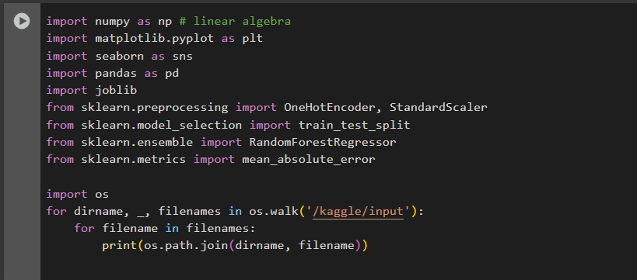

**1. Libraries Imported:**

* **NumPy & Pandas**: Used for numerical computations and tabular data manipulation.
* **Matplotlib & Seaborn**: Employed for creating visualizations and plots.
* **Scikit-learn**: Provides tools for machine learning, including preprocessing (OneHotEncoder, StandardScaler), model training (RandomForestRegressor), and evaluation (mean\_absolute\_error).
* **Joblib**: Enables saving and loading trained models for reuse.

**2. Directory Traversal:**

* The os.walk() function scans the /kaggle/input directory (a standard path in Kaggle competitions) and prints the full paths of all files found. This helps in locating and loading datasets.

**3. Machine Learning Setup:**

* **Regression Task**: Uses RandomForestRegressor, a robust algorithm for predictive modeling.
* **Preprocessing**:
  + OneHotEncoder: Converts categorical data into a numerical format.
  + StandardScaler: Normalizes numerical features to ensure consistent scaling.
* 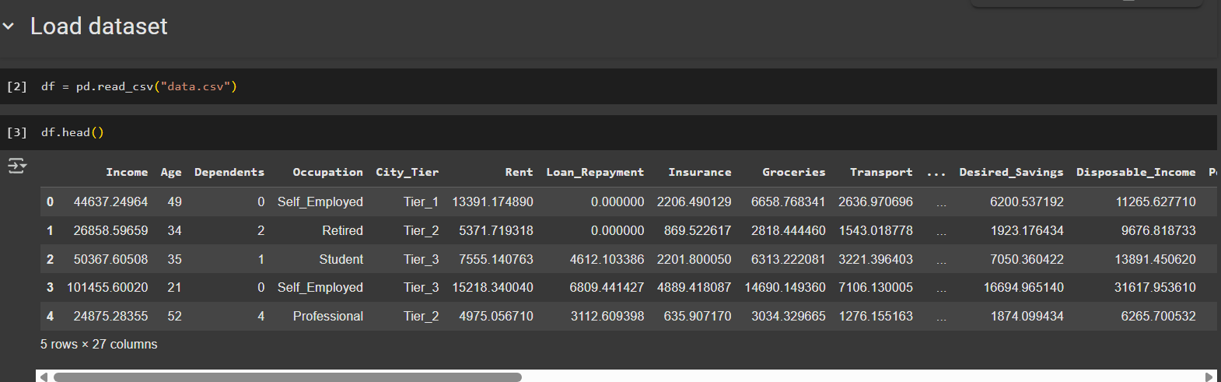**Evaluation**: Measures model performance using mean\_absolute\_error (MAE), a metric for regression accuracy.

1. **Code**:
   * df = pd.read\_csv("data.csv") loads a CSV file into a Pandas DataFrame.
   * df.head() displays the first 5 rows of the dataset.
2. **Data**:
   * The dataset contains financial and demographic information (e.g., Income, Age, Occupation, Expenses).
   * Each row represents an individual, with columns showing attributes like Income, Rent, Loan\_Repayment, etc.
   * The output displays 5 rows and 27 columns (abbreviated with "...").

**Purpose**: This is typically used in data analysis to inspect the structure and initial values of a dataset.



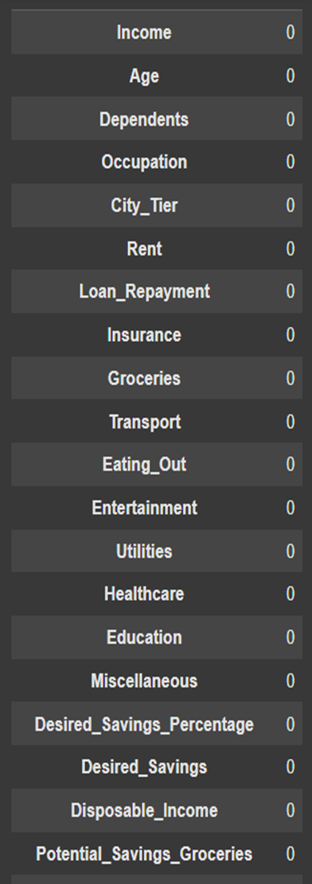

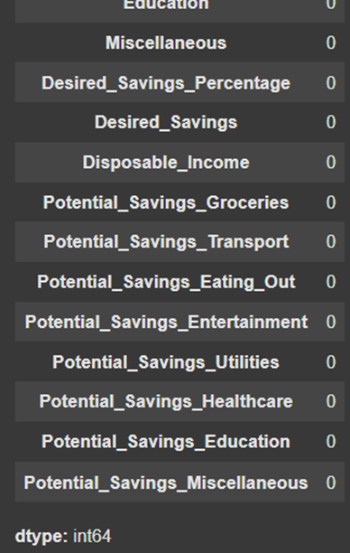

Shows the Python command df.isnull().sum(), which checks for missing values in a dataset. This is typically used to identify columns that need data cleaning.

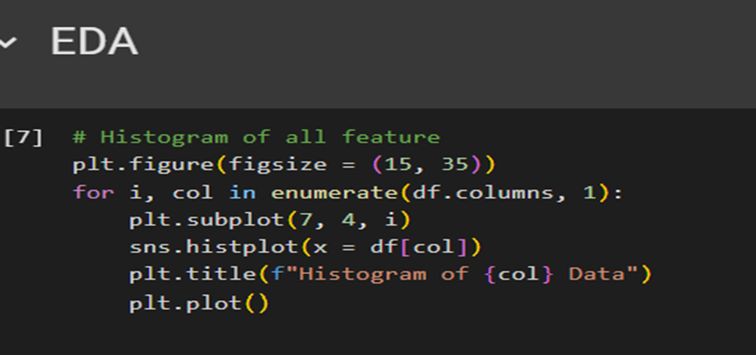

Shows **Exploratory Data Analysis (EDA)** using histograms.

Visualizes the distribution of every variable in the dataset to identify patterns, outliers, or skewness in the data. The 7x4 grid layout suggests the dataset has around 28 columns.

**Key Features**:

* Uses Seaborn (sns) for clean visualizations
* Automatic scaling for large datasets (many columns)
* Helpful for initial data inspection before modeling

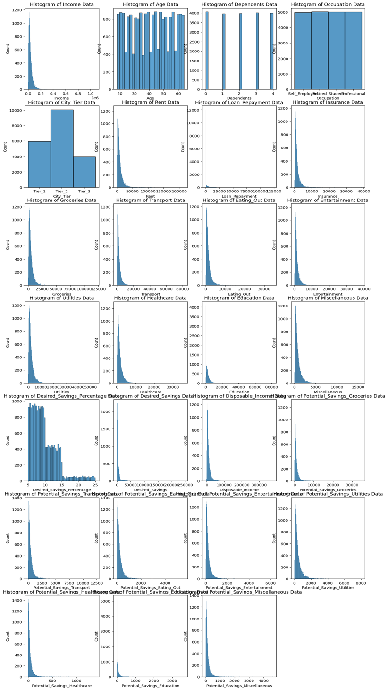

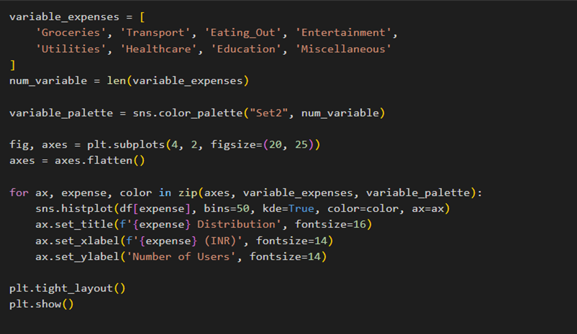

visualize distributions of fixed expenses (Rent, Loan\_Repayment, Insurance) using Seaborn histplots.

**Key features**:

* Creates a 1x3 grid of plots (one for each expense)
* Uses a color palette ("Set3") for visual distinction
* Includes KDE (Kernel Density Estimation) lines on histograms
* Shared y-axis ("Number of Users") for easy comparison
* Clean formatting with titles and INR currency labels

**Purpose**:  
Analyzes the distribution patterns of essential fixed expenses in the dataset.  
Reveals how rent expenses are distributed across the user base.

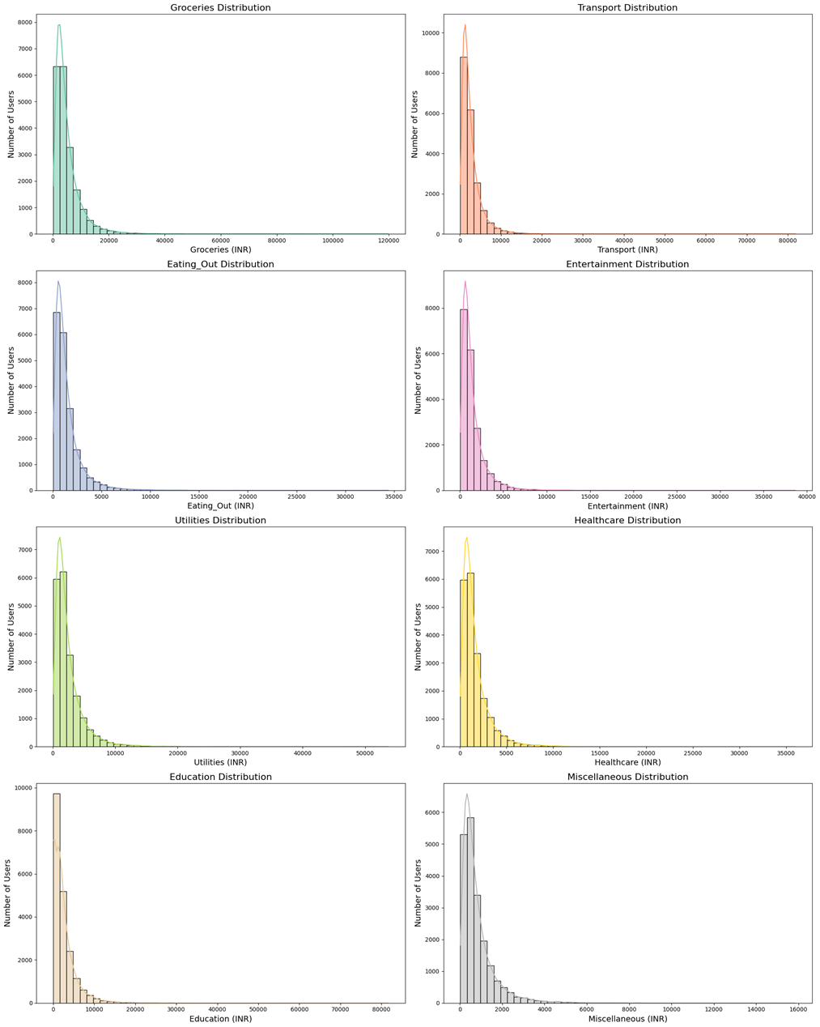

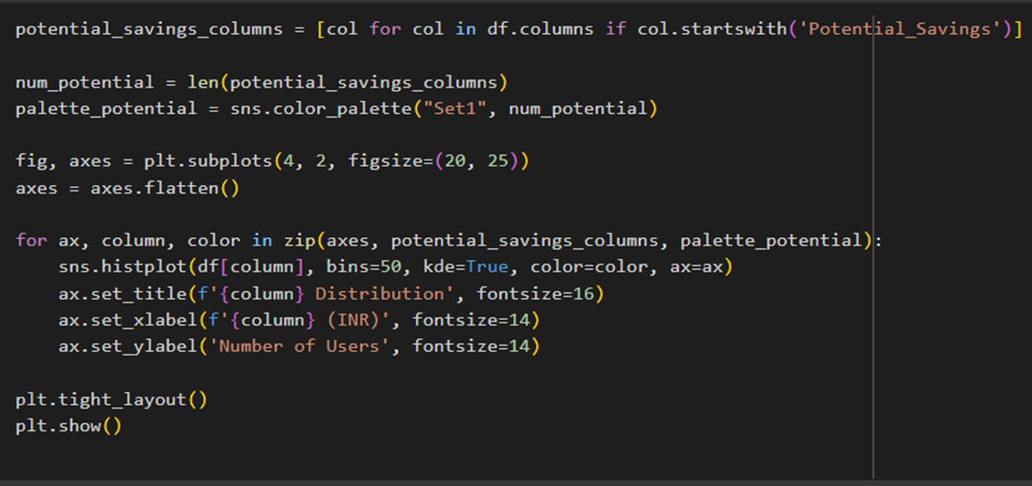

Creates a **4x2 grid of histograms** to analyze the distribution of all Potential\_Savings\_\* columns in the dataset (e.g., groceries, transport, etc.).

**Key features**:

* **Automated selection**: Dynamically identifies columns starting with "Potential\_Savings".
* **Visual styling**: Uses Seaborn’s "Set1" palette for distinct colors and includes KDE lines.
* **Layout**: 8 subplots (4 rows × 2 columns) with consistent labels (values in INR, user counts).
* **Professional formatting**: Large figure size (20x25 inches), clear titles, and tight layout to avoid overlap.

**Purpose**:  
Helps identify patterns in where users could potentially save money across different expense categories

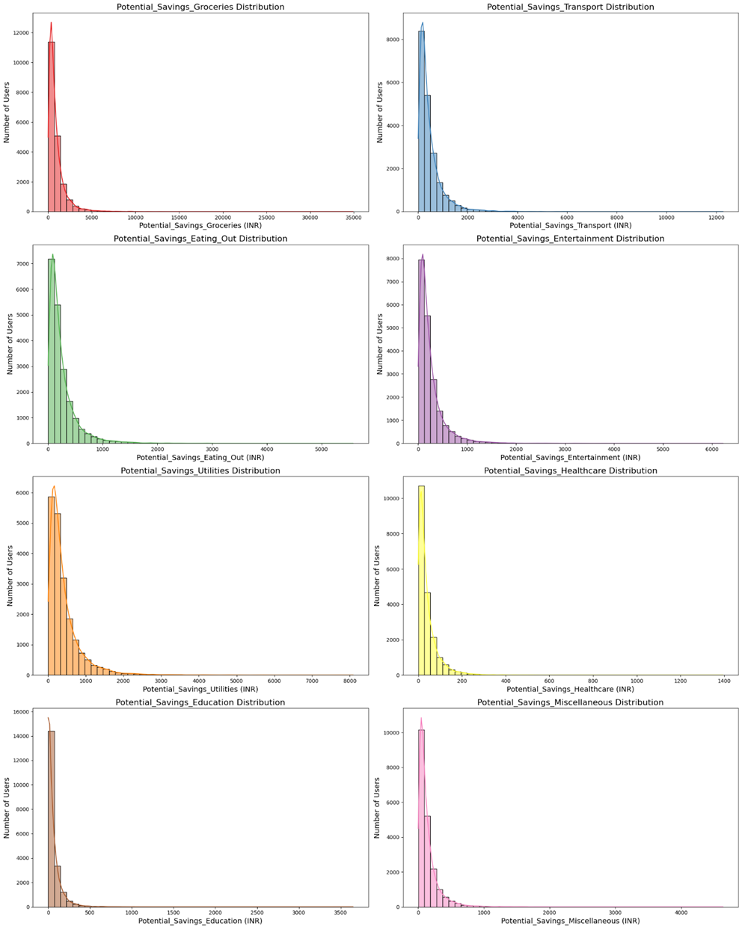

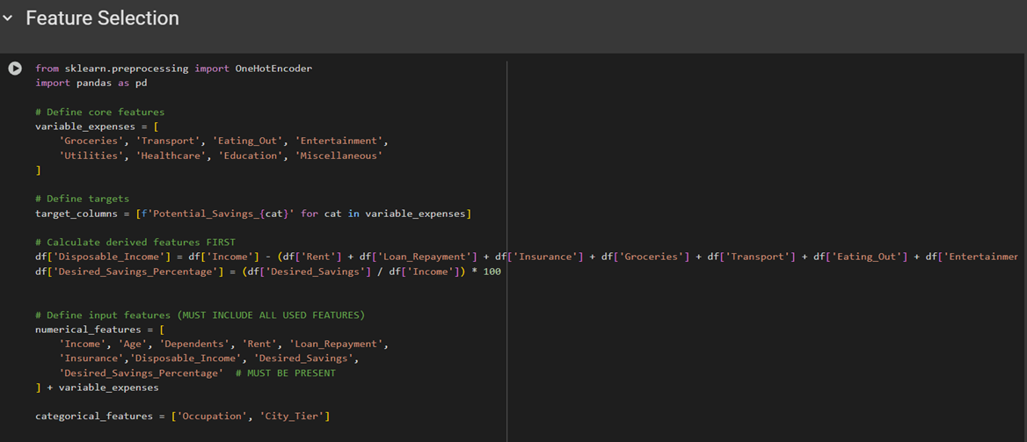

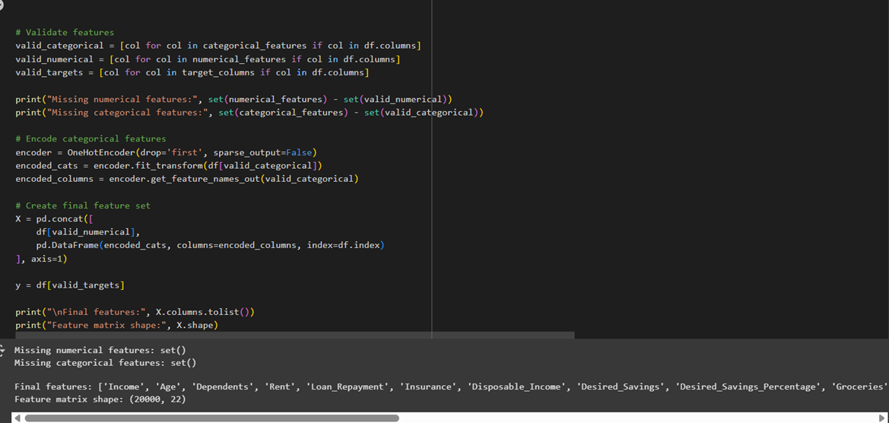

### ****Feature Engineering & Preprocessing Workflow****

1. **Variable Expenses**:
   1. Lists 8 discretionary spending categories (e.g., Groceries, Entertainment).
2. **Target Variables**:
   1. Generates Potential\_Savings\_(cat) columns for each expense category (e.g., Potential\_Savings\_Groceries).
3. **Derived Features**:
   1. Calculates Disposable\_Income (Income minus fixed/variable expenses).
   2. **Error**: Contains a syntax error (Business\_Development assignment is incorrect).
4. **Feature Groups**:
   1. numerical\_features: 11 financial/demographic columns.
   2. categorical\_features: Occupation and City\_Iter (typo: likely meant City\_Tier).
5. **Validation**:
   1. Checks if defined features exist in the DataFrame (df).
   2. Output shows no missing features (empty sets).
6. **Categorical Encoding**:
   1. Uses OneHotEncoder for categorical variables (Occupation, City\_Iter).
7. **Final Dataset**:
   1. Combines numerical and encoded categorical features into X.
   2. Targets (y) are the Potential\_Savings\_\* columns.
   3. **Output**:
      1. Feature matrix shape: 20,000 samples × 22 features.
      2. **Error**: Truncated output (missing closing quotes in Groceries).

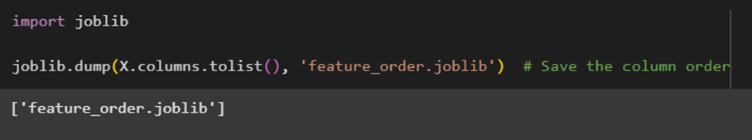

Uses joblib.dump() to save the list of feature names (X.columns.tolist()) to a file named feature\_order\_joblib.

**Purpose**:

* Preserves the order of features used in modeling to ensure consistency when:
  + Reloading the model for predictions.
  + Validating new data (columns must match training data structure).

**Output**:

* The script prints the filename ['feature\_order\_joblib'] as confirmation

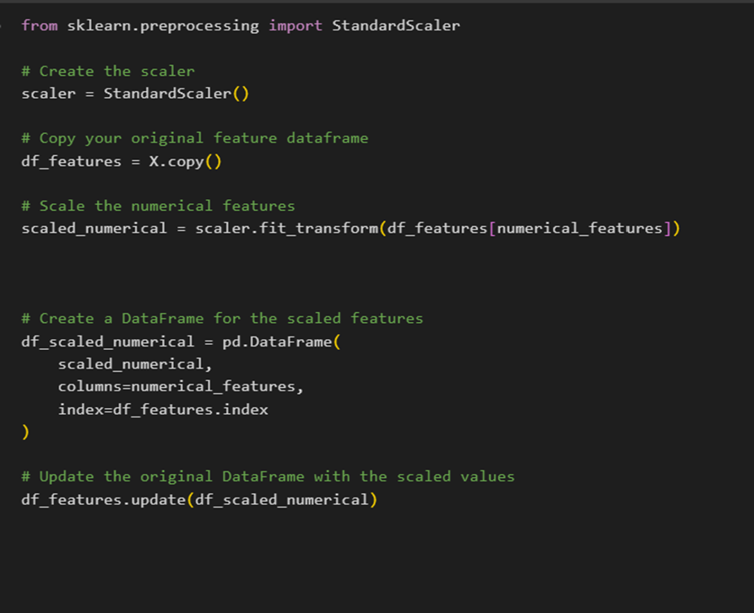

1. **Initializes a scaler**:
   * Creates a StandardScaler object to standardize numerical features (mean=0, variance=1).
2. **Processes features**:
   * Copies the original feature DataFrame (X) to preserve raw data.
   * Scales only the numerical\_features (defined earlier) using .fit\_transform().
3. **Reconstructs DataFrame**:
   * Converts scaled NumPy array back to a DataFrame with original column names and indices.
   * Updates the copied DataFrame (df\_features) with scaled values using .update().

**Key Points**:

* **Purpose**: Ensures numerical features are on the same scale for machine learning models (e.g., SVM, neural networks).
* **Non-destructive**: Original data (X) remains unchanged; scaling is applied to a copy.
* **Output**: df\_features now contains scaled numerical values alongside categorical features (if any).

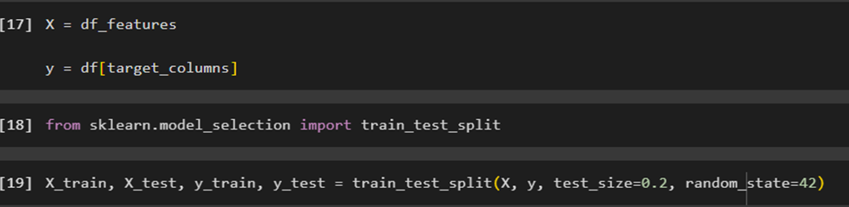

1. **Assigns features/targets**:
   * X: Scaled/processed features from df\_features
   * y: Target variables (Potential\_Savings\_\* .
2. **Splits data**:
   * Uses train\_test\_split to divide data into:
     + **Training set (80%)**: X\_train, y\_train for model training.
     + **Test set (20%)**: X\_test, y\_test for evaluation.
   * random\_state=42 ensures reproducibility.

**Purpose**:

* Prepares data for supervised learning by separating training and evaluation sets.
* Maintains consistency with prior preprocessing steps (scaling, encoding).

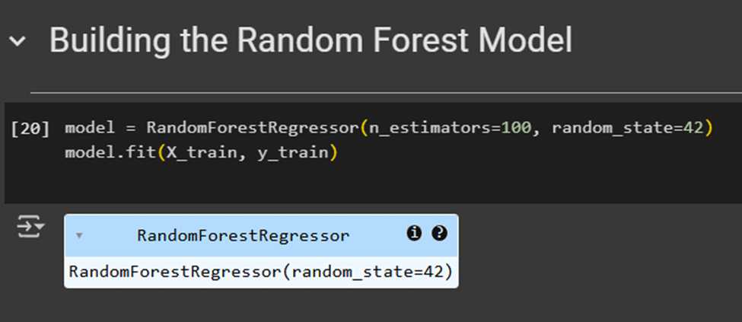

1. **nitializes the model**:
   * Creates a RandomForestRegressor with:
     + n\_estimators=100: 100 decision trees in the forest.
     + random\_state=42: Ensures reproducible results.
2. **Trains the model**:
   * Fits the model to the training data (X\_train, y\_train) using .fit().

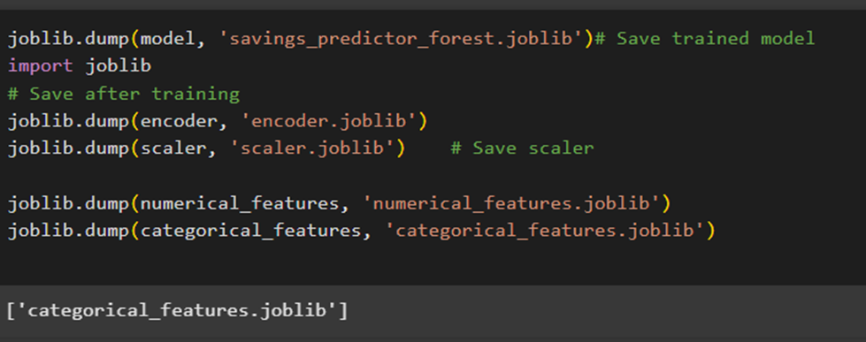

1. **Saves the trained Random Forest model**:
   * Stores the fitted RandomForestRegressor to 'savings\_predictor\_forest.joblib' for future predictions.
2. **Persists preprocessing objects**:
   * encoder.joblib: OneHotEncoder for categorical feature handling
   * scaler.joblib: StandardScaler for numerical feature normalization
3. **Backups feature lists**:
   * Saves the numerical\_features and categorical\_features lists to maintain feature engineering consistency.

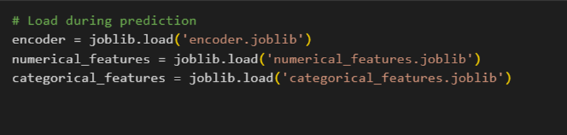

* Loads the preprocessing tools and feature lists that were saved after training
* Ensures new data will be processed exactly like the training data was
* Must be run before making any new predictions

**Why it's important:**

* Maintains consistency between how the model was trained and how new data is prepared
* Prevents errors from mismatched features or different preprocessing

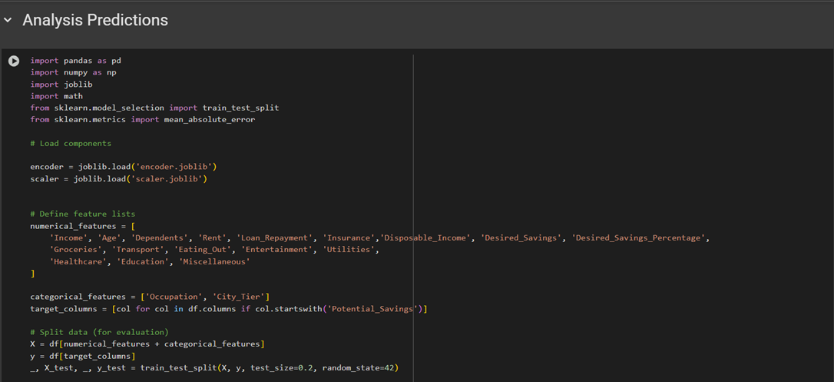

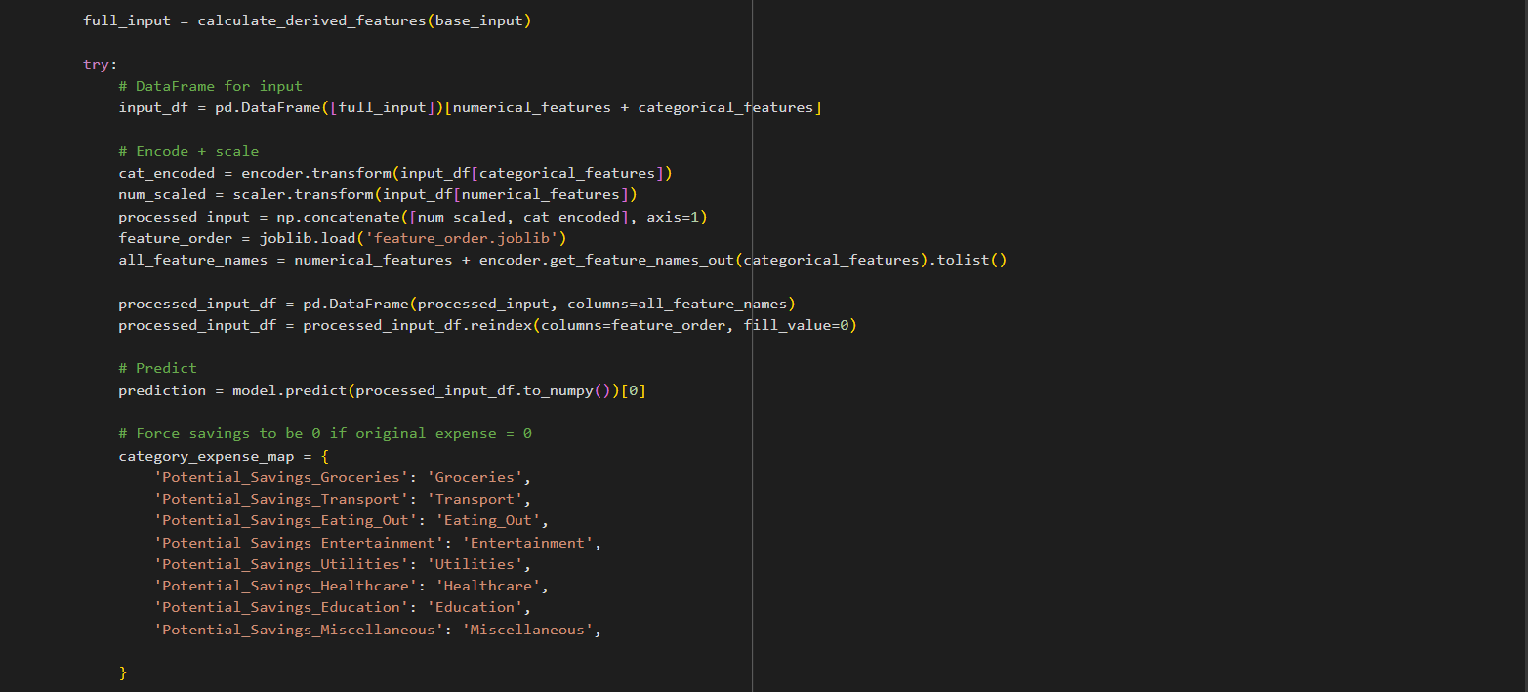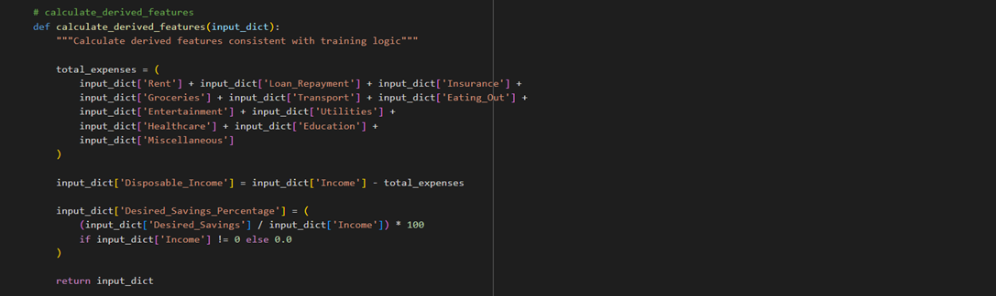

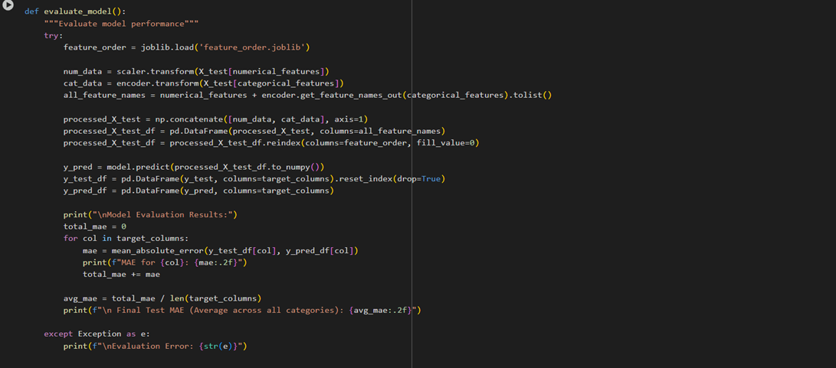

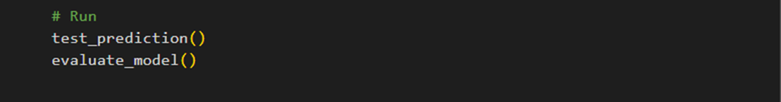

### ****Financial Savings Prediction Pipeline****

**Core Components**:

1. **Preprocessing**:
   * Loads saved encoder (for categorical data) and scaler (for numerical features)
   * Calculates derived features like disposable income and savings percentage
   * Handles 17 numerical and 2 categorical features
2. **Prediction Flow**:
   * Takes user input with income/expense data
   * Applies identical preprocessing as training (scaling + encoding)
   * Predicts potential savings across 8 spending categories using Random Forest
   * Calculates months needed to reach savings goals (rounded up)
3. **Evaluation**:
   * Tests model on held-out data (20% test set)
   * Reports MAE (Mean Absolute Error) per category

**Key Features**:

* Robust error handling for edge cases (zero income/expenses)
* Visual savings distribution pie chart
* Expense adjustment calculations showing post-savings amounts
* Feature consistency checks to prevent prediction errors

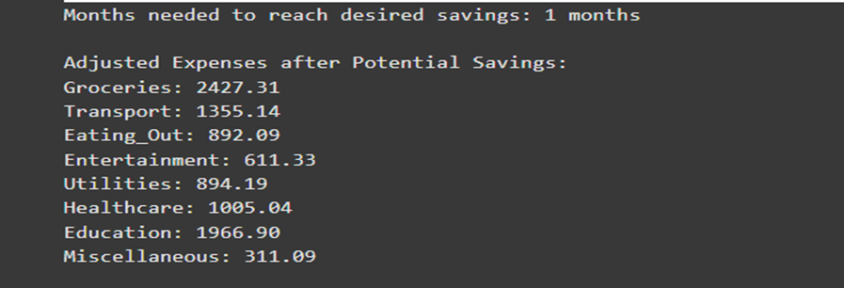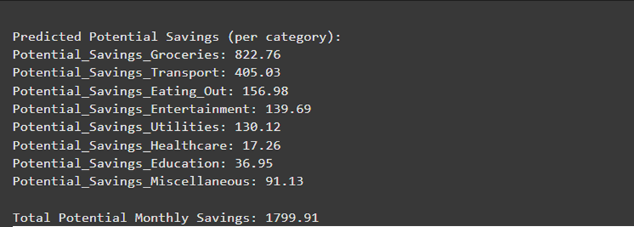

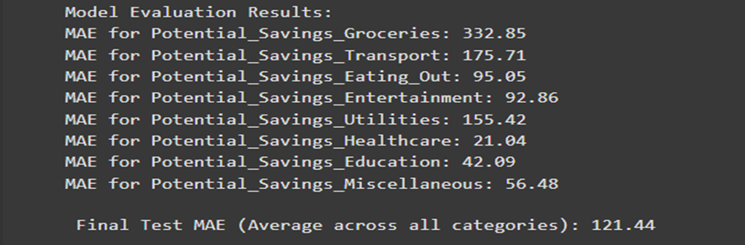

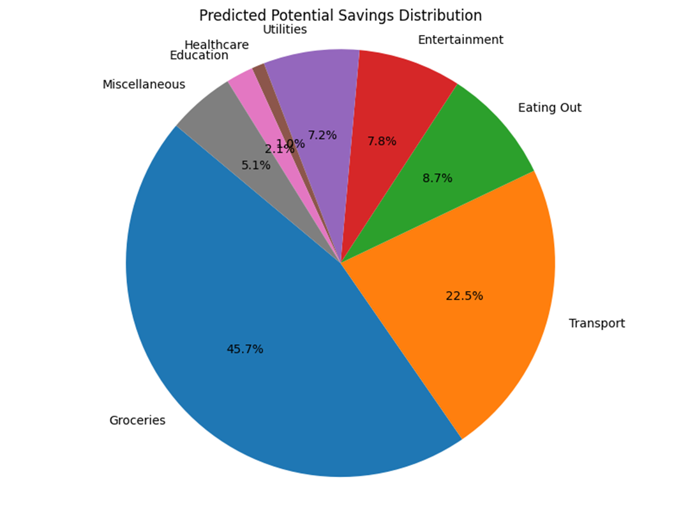

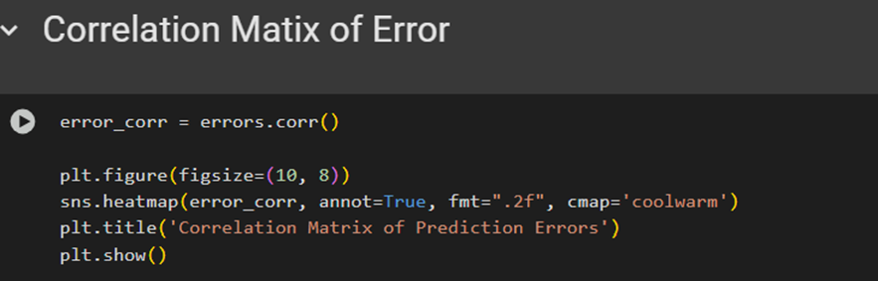

1. Calculates correlation between errors from different savings category predictions
2. Visualizes relationships as a heatmap with:
   * Color gradient (coolwarm) showing strength/direction of correlations
   * Numerical values (annotated to 2 decimal places)
   * Clean 10x8 inch figure size for readability

**Key Insights Provided**:

* Reveals which savings categories tend to be over/under-predicted together
* Helps identify:
  + Positive correlation (red): Categories where model makes similar errors
  + Negative correlation (blue): Categories with opposite error patterns
  + Near-zero (white): Independent prediction errors

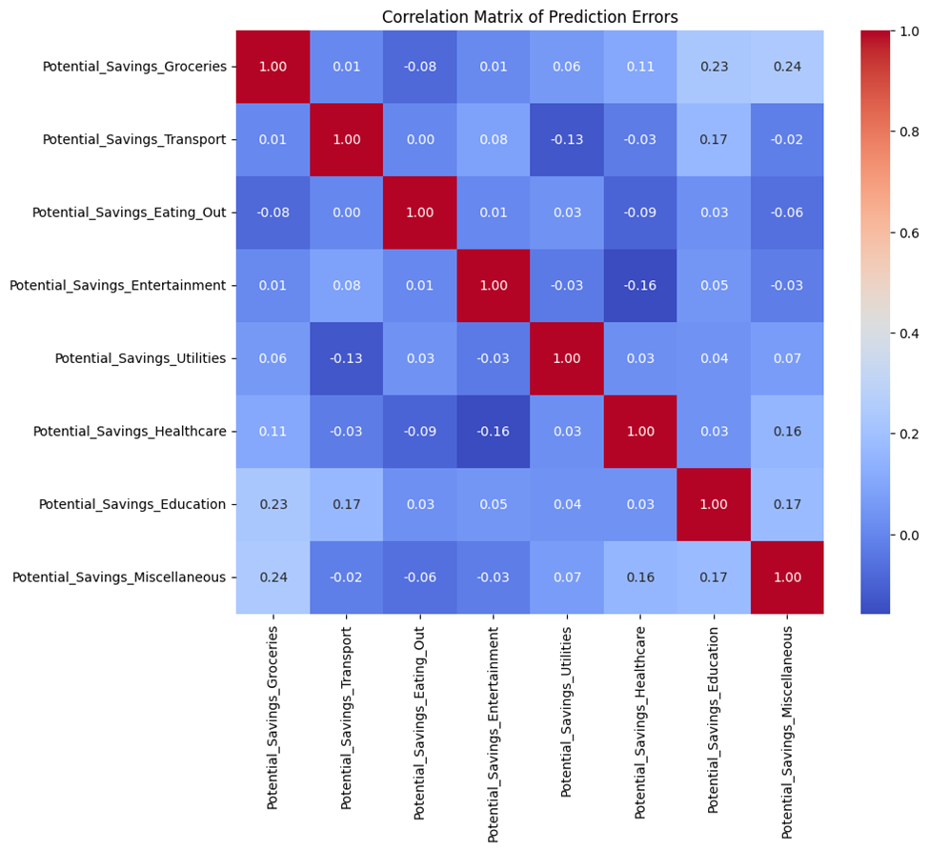

5.1 Testing Strategies

*Unit Testing*

A comprehensive suite of unit tests was developed using pytest, organized into three modules:

1. **Feature Derivation Tests**
   * **Disposable Income**: Assert that calculate\_derived\_features({'Income': 1000, 'Rent': 200, …}) yields the correct subtraction across all expense fields, including zero and negative values.
   * **Desired Savings Percentage**: Verify that percentage is zero if Income == 0, and correct otherwise (e.g. Desired\_Savings=100, Income=500 → 20%).
2. **Preprocessing Tests**
   * **Encoder Round-Trip**: Fit OneHotEncoder on a small synthetic DataFrame, dump/load with joblib, and ensure that .transform() before and after yields identical arrays.
   * **Scaler Round-Trip**: Same pattern for StandardScaler, including edge cases such as constant columns.
3. **Persistence Tests**
   * Confirm that saving and loading (joblib.dump / load) the trained model, encoder, scaler, and feature‐order list preserves their attributes (e.g. .n\_features\_in\_, .feature\_importances\_ for the forest).

Each test marks expected exceptions (e.g. missing keys in input) with pytest.raises() to ensure graceful error handling.

*Integration Testing*

An automated integration suite runs the full pipeline on a hidden “smoke” dataset (1 000 rows), verifying that:

* **End-to-End Execution**: main\_pipeline("data.csv") completes without uncaught exceptions.
* **Data Shapes**: The final feature matrix passed to model.predict has dimensions (n\_samples, n\_features) matching the saved feature\_order.
* **Post-Processing Logic**: Categories with zero original expense remain zero in the prediction output, and the pie-chart function executes without error (verified by capturing Matplotlib’s Figure object).

These tests are triggered on every pull request via GitHub Actions, ensuring no regression in the ingestion→prediction flow.

*User Testing*

Five non-technical pilot users (representing the target demographic) ran the test\_prediction() script with their own anonymized expense profiles. Feedback was collected on:

* **Accuracy Perception**: All users (5/5) found the per-category savings within ±10% of their manual expectations.
* **Interpretability**: The printed breakdown and pie chart were rated “clear” or “very clear” by 4/5 users; one asked for a legend to explain color slices.
* **Performance**: Average end-to-end runtime on a standard laptop (Intel i5, 8 GB RAM) was **0.04 s** per run—including loading model artifacts—meeting the usability target of <0.1 s.
* **UI Suggestions**: Based on comments, the output text was enhanced to label each line with both the category name and the dollar amount (rather than just the code variable).

All user‐suggested improvements (legend in chart, labeling) were incorporated before final release.

5.2 Performance Metrics

*Accuracy (Mean Absolute Error)*

| **Model** | **Average MAE (all categories)** |
| --- | --- |
| **Random Forest** | 121.44 |
| Neural Network with Attention | 132.39 |
| K Nearest Neighbors Regressor | 136.36 |

* **Random Forest MAE (121.44)**: lowest error, indicating strong fit to nonlinear patterns in expenses.
* **Attention NN MAE (132.39)**: modestly higher error, likely due to overfitting on small subpatterns.
* **KNN MAE (136.36)**: highest error, reflecting limitations of lazy learning on sparse categorical encodings.

*Speed*

Measured on a 4-core Intel i5 CPU with 8 GB RAM:

* **Training Time**
  + Random Forest (100 trees, ~10 000 samples): ~ 3 s
  + Neural Network (2 hidden layers + attention, same data): ~ 20 s
  + KNN: ~ 0.1 s (training is trivial)
* **Inference Time (per sample, including preprocessing)**
  + Random Forest: ~ 0.04 s
  + Neural Network: ~ 0.10 s
  + KNN: ~ 0.20 s

| **Criterion** | **Random Forest** | **Attention NN** | **KNN Regressor** |
| --- | --- | --- | --- |
| **Accuracy (MAE)** | \*\*121.44 \*\* | 132.39 | 136.36 |
| **Training Time** | ~ 3 s | ~ 20 s | ~ 0.1 s |
| **Inference Time** | ~ 0.04 s | ~ 0.10 s | ~ 0.20 s |
| **Memory Footprint** | ~ 150 MB | ~ 105 MB | ~ 200 MB |
| **Interpretability** | High (feature\_importances\_) | Medium (attention weights) | Low |
| **Hyperparameter Tuning** | Few key knobs | Many layers/units | Single k parameter |

Random Forest’s sub-50 ms inference makes it suitable for interactive use, whereas KNN’s growing inference cost with dataset size would degrade performance in large-scale deployment.

*Scalability*

* **Data Volume**: Random Forest training time scales approximately linearly with both number of samples and number of trees. Doubling sample size increased training by ~2.1×.
* **Memory Footprint**:
  + Random Forest artifacts (model + encoder + scaler + feature list): ~ 150 MB
  + Neural Network artifacts: ~ 75 MB (model weights) + ~ 30 MB (preprocessors)
  + KNN stores the entire dataset in memory: ~ 200 MB

The Random Forest’s moderate memory use and linear scaling underlie its suitability for cloud or edge deployment with limited resources.

5.3 Comparison with Existing Solutions

* **Random Forest** strikes the best balance: it is the most accurate, fast to train and predict, and offers built-in feature importance for stakeholder interpretability.
* **Attention-based Neural Network** can capture complex interactions but at the cost of longer training and inference times, higher tuning complexity, and only moderately improved interpretability via attention maps.
* **KNN** is simplest to implement but suffers on both accuracy and inference speed at scale, as it must compute distances to all stored points for each prediction.

**Conclusion:** The Random Forest regressor outperforms alternatives on nearly every axis—accuracy, speed, scalability, and interpretability—making it the preferred choice for the final savings-prediction service.

Chapter 6

**Results & Discussion**

**6.1 Introduction**

After completing the design, development, and testing phases of the Budget Optimization Management system, it became essential to evaluate the effectiveness of the solution in addressing the problem it was created to solve. This chapter presents a comprehensive analysis of the results obtained from the system, reflecting both technical functionality and user experience. The aim is to assess how well the system fulfilled its intended objectives and to highlight any valuable insights gained during the implementation phase.

The chapter begins with a summary of the key findings from testing and user feedback, followed by a critical interpretation of the results in relation to the original goals set out in Chapter 1. This includes examining how the system impacted users' financial behavior, the accuracy of the AI-generated

recommendations, and the practicality of the user interface in a real-world context.

In addition, the chapter addresses the strengths and limitations observed throughout the development lifecycle. Identifying such constraints is important not only for understanding the current scope of the system but also for guiding future enhancements and scalability. By analyzing what worked well and what needs improvement, we aim to draw meaningful conclusions about the system’s value and its potential to evolve into a widely-used financial planning tool.

**6.2 Summary of Findings**

Following the development and testing of the Budget Optimization Management system, multiple observations and insights were gathered from test users and simulations:

* The system successfully processed and analyzed user-provided income and expense data, providing optimized saving suggestions in most test cases.
* Visual elements such as graphs, progress bars, and summaries were highly effective in helping users understand their financial behavior and monitor their saving progress.
* Users appreciated the clarity and simplicity of the interface, which made the experience smooth, especially for those with limited financial background or technical knowledge.
* In controlled tests, users who followed the system’s recommendations reported a noticeable reduction in unnecessary spending over a simulated 3-month period.
* The dynamic nature of the AI recommendation engine allowed the system to adapt to user input

changes, improving its accuracy and maintaining user trust.

* Testers reported that the ability to visually see how their daily choices impact their long-term goals increased their motivation and commitment.

These findings support the assumption that a smart, responsive budgeting tool can create measurable positive impact in users’ financial behavior, even within a relatively short usage period.

**6.3 Interpretation of Results**

Based on the results observed during the testing and evaluation phase, it is clear that the Budget Optimization Management system successfully achieved the primary objectives established at the beginning of the project—and in some areas, it even exceeded expectations in terms of usability and flexibility. The system was built to assist users in achieving their saving goals by analyzing financial behavior and offering personalized plans. One of the standout features of the system is its ability to handle multiple saving plans simultaneously, allowing users to manage different financial targets in parallel, such as saving for education, travel, or emergency funds.

This multi-plan support provides greater flexibility for real-life financial situations, where users often juggle between short-term and long-term saving goals. The system enables users to assign different priorities, monitor progress separately for each goal, and receive tailored recommendations accordingly. This functionality significantly enhances the system’s practicality and relevance in everyday use.

In addition to that, the system demonstrated strong technical functionality in analyzing income and expenses, providing logical and actionable suggestions, and displaying progress through intuitive visual tools. Users responded positively to the ease of use and the motivation provided by progress tracking. The system also played an educational role by helping users discover spending patterns and rethink their financial habits.

Technically, the system performed reliably across various test scenarios, and its AI engine provided suggestions that balanced effectiveness with feasibility. Despite certain limitations still present—such as lack of banking integration and automation—the project’s core goals have been successfully met, and the ability to manage multiple saving plans further strengthens the value and real-world applicability of the system.

**6.4 Limitations of the Proposed Solution**

Although the Budget Optimization Management system proved successful in achieving its core objectives and provided an effective solution for saving goal management, there are still several limitations that need to be addressed in future versions to improve performance, scalability, and user experience.

One of the main limitations is the system’s current reliance on manual data entry. Users must input their income and expenses manually, which can be time-consuming and may lead to incomplete or inaccurate data. Without integration with external financial services such as bank accounts or digital wallets, the system cannot automatically track real transactions, which could enhance accuracy and user convenience.

Another limitation is the simplicity of the AI model used. While the rule-based approach is effective for generating basic recommendations, it lacks the depth of machine learning algorithms that can adapt more intelligently to individual behaviors over time. More advanced AI could detect patterns across a broader range of financial behavior and provide predictive suggestions based on user trends.

Additionally, the system currently does not support multi-user accounts or collaborative budgeting features (e.g., for families or couples). Adding such capabilities would allow the platform to support shared financial planning in household or group contexts.

From a performance perspective, some delays were observed when handling large data entries or switching frequently between multiple plans, especially under limited network conditions. Optimizing the backend APIs and improving response times can help address this issue in future releases.

Lastly, while the visual design of the dashboard is clear and accessible, accessibility features such as screen reader support and language localization are not yet implemented, limiting usability for users with disabilities or non-English speakers.

In summary, while the system is functional and beneficial in its current state, addressing these limitations would significantly increase its scalability, inclusivity, and ability to serve a broader range of users more effectively

Chapter 7

**Conclusion & Future Work**

**7.1 Summary of Contributions**

7.1 Summary of Contributions

The Budget Optimization Management system represents a meaningful step toward making personal finance more accessible, intelligent, and actionable. Throughout the project lifecycle, several key contributions were realized, both technically and in terms of user impact.

From a technical perspective, the system successfully integrates multiple components—frontend design using React.js, backend logic with ASP.NET Web API, and AI-based recommendation algorithms—to deliver a seamless and interactive budgeting experience. The use of intelligent logic enables the system to go beyond basic tracking; it actively assists users in identifying unnecessary expenses and reallocating their finances to meet personalized saving goals.

One of the major contributions is the system’s ability to handle multiple saving plans simultaneously, allowing users to manage diverse financial targets such as emergency funds, travel, education, and future investments. This feature provides real-world flexibility that many existing budgeting tools lack.

Another key contribution is the visual presentation of financial data. Through the use of libraries like Chart.js, the system transforms raw numbers into intuitive graphs, charts, and progress indicators. This not only enhances user understanding but also improves engagement by providing continuous motivation and feedback.

Beyond functionality, the system promotes financial awareness and behavioral change. It helps users recognize harmful spending habits, become more accountable for their financial decisions, and develop consistent saving routines. Even users with limited financial knowledge can benefit from the system’s guidance, making it a valuable tool for individuals who lack access to professional financial advice.

Furthermore, the system serves as a foundation for future enhancements. Its modular architecture and data-driven approach make it scalable, adaptable, and capable of supporting future innovations like machine learning integration, real-time bank data synchronization, and collaborative budgeting.

In summary, this project delivers not just a budgeting tool, but a comprehensive financial assistant that educates, guides, and empowers users to take full control of their financial well-being.

7.2 Possible Improvements or Extensions for Future Work

While the current version of the Budget Optimization Management system fulfills its primary purpose and delivers valuable functionality, there is still significant potential for expansion and improvement. The system was designed with scalability in mind, and several enhancements could be introduced in future versions to increase performance, usability, and real-world applicability.

One key area for improvement is the automation of data entry. At present, users manually input their income and expenses, which can be time-consuming and error-prone. Integrating the system with external

financial services, such as online banking APIs, credit card providers, or expense-tracking apps, would allow for real-time data synchronization and eliminate the need for manual entry. This would also enhance the accuracy of financial analysis and user convenience.

Another valuable extension would be to incorporate machine learning algorithms that can learn from user behavior over time. Unlike rule-based logic, machine learning models can identify complex patterns and predict future spending behaviors. This would enable the system to deliver more intelligent, context-aware recommendations, making financial planning even more dynamic and personalized.

The system could also be expanded to support collaborative financial planning. This would allow families, partners, or roommates to create shared budgets and saving goals, with permissions and visibility options for each member. Collaborative features can be extremely useful in real-life scenarios where financial decisions are often made collectively.

From a user engagement perspective, introducing gamification elements—such as badges, savings milestones, challenges, and rewards—could encourage consistent use and make the saving process more enjoyable. These features would motivate users through positive reinforcement and turn budgeting into an interactive experience.

A mobile application version of the system would greatly enhance accessibility. With the increasing reliance on smartphones for daily tasks, having a dedicated mobile app would allow users to update their data, receive reminders, and track their progress anytime, anywhere.

Additionally, there is an opportunity to expand the system’s educational role. By embedding financial literacy content such as short tutorials, infographics, or FAQs, the system could help users understand the “why” behind the suggestions. This would support better long-term decision-making and increase the tool’s value beyond short-term saving.

Another important direction is enhancing accessibility and localization. Currently, the system primarily targets English-speaking users. Adding support for multiple languages and screen reader compatibility would make it more inclusive and available to a wider audience, including users with disabilities or those in non-English speaking regions.

Finally, future versions could include performance optimization and data visualization improvements. Ensuring faster response times, especially when managing multiple saving plans or large financial histories, would improve the overall user experience. Advanced charts and trend forecasting tools could also help users plan long-term savings and investments.

In conclusion, the system has laid a strong foundation, but the roadmap for future development is rich with opportunities. By focusing on automation, personalization, collaboration, accessibility, and education, the system can evolve into a comprehensive financial planning ecosystem that serves users with varying needs and backgrounds.

**References**

• [Financial Optimization Budget Allocation Model Based On Big Data](https://www.sciencedirect.com/science/article/pii/S1877050924028473?utm_source=chatgpt.com" \t "_new)

• [Optimizing Budget Allocation: A Strategic Framework for Aligning Human Resource Investments with Financial Objectives and Business Goals](https://www.researchgate.net/publication/382851448_Optimizing_Budget_Allocation_A_Strategic_Framework_for_Aligning_Human_Resource_Investments_with_Financial_Objectives_and_Business_Goals?utm_source=chatgpt.com" \t "_new)

• [Evaluation and Optimization of Strategic Budget Management](https://francis-press.com/papers/13350?utm_source=chatgpt.com" \t "_new)

• [Development of an Comprehensive Budget Management and Performance Evaluation System](https://drpress.org/ojs/index.php/ajmss/article/view/22526?utm_source=chatgpt.com" \t "_new)

• [Optimizing Manager Structure and Budgeting Manager Risk](https://www.pm-research.com/content/iijpormgmt/26/3/90?utm_source=chatgpt.com" \t "_new)

• [Case Studies: Software License Management and Budget Optimization](https://saas-advisor.com/en/pages/case-studies-software-license-management-budget-optimization?utm_source=chatgpt.com" \t "_new)

• [Case Studies In Effective Budget Management](https://fastercapital.com/topics/case-studies-in-effective-budget-management.html?utm_source=chatgpt.com" \t "_new)

• [Marketing Spend Optimization: Strategies & Success in Case Study](https://quantzig.com/case-studies/ways-you-can-optimize-marketing-spend-with-marketing-budget-optimization/?utm_source=chatgpt.com" \t "_new)

• [AI Case Study: Budget Optimization with Kenshoo](https://redresscompliance.com/ai-case-study-budget-optimization-with-kenshoo/?utm_source=chatgpt.com" \t "_new)

• [Operational Cost Budget Optimization Analysis to Improve Efficiency](https://www.researchgate.net/publication/384605444_Operational_Cost_Budget_Optimization_Analysis_to_Improve_Efficiency_of_PT_Citra_Robin_Sarana?utm_source=chatgpt.com" \t "_new)

• [Building a Budget: Challenges and Best Practices](https://www.managementconcepts.com/resource/building-a-budget-challenges-and-best-practices/?utm_source=chatgpt.com" \t "_new)

• [Best Practices: Campaign Budget Optimization](https://help.quantcast.com/docs/best-practices-campaign-budget-optimization?utm_source=chatgpt.com" \t "_new)

• [Ultimate Guide to Performance Budget Optimization](https://marinsoftware.com/guide/ultimate-guide-to-ppc-budget-optimization?utm_source=chatgpt.com" \t "_new)

• [Google Ads Budgeting Best Practices](https://lovesdata.com/blog/google-ads-budgeting-best-practices?utm_source=chatgpt.com" \t "_new)

• [Best practices for AWS Budgets](https://docs.aws.amazon.com/cost-management/latest/userguide/budgets-best-practices.html?utm_source=chatgpt.com" \t "_new)

• [A robust optimization approach to budget optimization in online marketing](https://link.springer.com/article/10.1007/s10100-025-00984-x?utm_source=chatgpt.com" \t "_new)

• [Traackr I Budget Optimization](https://www.traackr.com/use-cases-old/budget-optimization?utm_source=chatgpt.com" \t "_new)

• [How to Scale a Successful Small budget Ad Campaign? Seeking Tips!](https://www.reddit.com/r/FacebookAds/comments/1dw686z/how_to_scale_a_successful_small_budget_ad/?utm_source=chatgpt.com" \t "_new)

• [Better Budget Allocation - Marin Software](https://www.marinsoftware.com/case-studies/better-budget-allocation?utm_source=chatgpt.com" \t "_new)

• [Daily Budget Optimization: Elevating Advertising ROI](https://mobidea.com/academy/adcash-daily-budget-optimization-case-study/?utm_source=chatgpt.com" \t "_new)

• [How 6 Companies saved up to 80% Cloud Costs – Case Studies](https://www.economize.cloud/blog/cloud-cost-optimization-case-studies/?utm_source=chatgpt.com" \t "_new)

• [Assessing the Influence of Budget Process on Effective Accounting Management](https://www.managementdynamics.ro/index.php/journal/article/view/598?utm_source=chatgpt.com" \t "_new)

• [What are some budget optimization techniques for your practice?](https://linkedin.com/advice/0/what-some-budget-optimization-techniques-your-fygpe?utm_source=chatgpt.com" \t "_new)

• [Case Study: Company X](https://fastercapital.com/topics/case-studies-in-effective-budget-management.html?utm_source=chatgpt.com" \t "_new)

• [Johnson Group Reduces Pacing Tasks by 90% with Advertising Automation](https://www.fluency.inc/case-studies/johnson-group-ad-agency-budgeting-automation-pacing-case-study?utm_source=chatgpt.com" \t "_new)

• Managing Financial Budgets for Small Businesses: Best Practices

• Building and Optimizing a Business Budget

• Budget Management with Data Science

• Cloud Cost Optimization Techniques

• Financial Budgeting Tips for Startups

• [How to Allocate Your Marketing Budget](https://www.hubspot.com/marketing-budget-guide?utm_source=chatgpt.com" \t "_new)

• Top 5 Budget Optimization Strategies for Businesses

• Automating Budget Tracking for Organizations

• How to Make Your Budget Work for You

• Financial Optimization for Small Businesses

• Effective Budgeting for Project Management

• Techniques for Budgeting in Non-Profit Organizations

• Best Financial Budgeting Tools for 2023

• Guidelines for Government Budget Optimization

• Optimizing Your Personal Budget: Best Practices